StegoShield: Steganography Tool Using Python

Submitted by:
Deepak Kumar Yadav

Preface
This report presents the development and implementation of StegoShield: Steganography Tool using Python. With the increasing need for secure communication and data privacy in the digital era, information hiding techniques such as steganography have gained significant importance. Steganography allows the concealment of sensitive information within various media formats (such as images, audio, and video files), making it possible to transmit data securely and discreetly.

The StegoShield application is designed as a user-friendly, versatile, and robust steganography tool that leverages Python’s extensive libraries and modular architecture. It combines multiple steganographic algorithms and modern encryption techniques to ensure both the confidentiality and integrity of hidden information. The project aims to serve as a practical solution for students, researchers, and professionals interested in data security, as well as a strong foundation for further exploration and enhancement in the field of information hiding.

This document details the motivation, features, design, and implementation aspects of StegoShield, along with its practical applications and future scope. Through this project, we aspire to contribute to the growing landscape of digital security tools by offering a reliable and customizable platform for steganography.

Synopsis
Title
StegoShield: Steganography Tool using Python

Introduction

The need for secure communication has never been greater in the digital age. Steganography—concealing information within other seemingly innocuous data—combined with cryptography, forms a powerful solution for protecting sensitive information from unauthorized access. This project, StegoShield, is designed as a Python-based desktop application that enables users to securely hide, encrypt, and retrieve confidential messages in various digital media formats, such as images, audio, and video files.

Objectives

- To provide a user-friendly, cross-platform tool for secure information hiding using steganography and cryptography.
- To support multiple media formats and robust encryption algorithms for maximum flexibility and security.
- To ensure extensibility and maintainability with modular code and comprehensive documentation.
- To implement rigorous testing and adhere to best software engineering practices for reliability and performance.

Methodology

The project was developed using a modular and incremental approach, following the Waterfall Model supplemented by iterative enhancement. Key phases included requirements analysis, system and software design, modular implementation, integration and testing, and deployment. Comprehensive unit, integration, and system testing were performed to ensure reliability and security. Technologies used include Python 3.x, Tkinter for the GUI, Pillow for image processing, OpenCV for video, pydub for audio, and PyCryptodome for encryption.

Features

- Steganography: Embed and extract secret messages in images, audio, and video files.

- Cryptography: Encrypt and decrypt messages using industry-standard algorithms (AES, DES, Blowfish, etc.).

- User Authentication: Secure login and access controls for different user roles.

- Operation History: Logging and viewing of past operations for audit and learning.

- Extensible Design: Modular structure allows for easy addition of new algorithms and features.

- Cross-Platform Compatibility: Runs on Windows, Linux, and macOS.

System Architecture

- ER Diagram: Models user, file, algorithm, operation history, and settings entities with their relationships.

- DFD Diagram: Illustrates the flow of data through authentication, embedding, extraction, and logging processes.

- Testing: Comprehensive testing methodology includes unit, integration, system, regression, security, and user acceptance testing.

Limitations

- Limited support for some media formats and large payloads.
- No advanced key management or automated plugin system.
- Absence of real-time collaboration and cloud-based features.
- Potential for misuse and subject to legal restrictions in certain jurisdictions.

Future Scope

- Integration of advanced steganography and cryptography algorithms.
- Web and mobile application development.
- Enhanced user experience and accessibility features.
- Cloud storage and sharing capabilities.
- Automated steganalysis and detection tools.
- API and plugin architecture for community-driven expansion.
- Educational modules and compliance with evolving security standards.

Conclusion

StegoShield stands as a robust, practical tool for secure communication, blending steganography and cryptography in an intuitive Python application. With room for future growth and adaptation, it serves both academic and professional needs, promoting the safe and confidential exchange of information in the digital era.

INDEX
S.NO | TOPIC | PAGE NO.
1. | 1. INTRODUCTION…………………………………………………….......  1.1 Purpose….……………………………………………………………….  1.2 Objective……………………………………………………………….  1.3 Scope……………………………………………………………………. | 6-8
2. | 2. THEORETICAL BACKGROUND DEFINITION OF PROBLEM….  2.1 Introduction…………………………………………………………….  2.2 Project Background…………………………………………………….  2.3 Problem Statement…...……………………………………….………. | 9-10
3. | 3. SYSTEM ANALYSIS & DESIGN…………………….…………………  3.1 System Design…………………………………………………………  3.2 System Architecture…………………………………………………….  3.3 Use Case Diagram…………………………………………………….  3.4 Activity Diagram………………………………………………………  3.5 Sequence Diagram…………………………………………………….  3.6 Class Diagram………………………………………………………… | 11-16
4. | 4. METHODOLOGY, IMPLEMENTATION AND REQUIREMENTS...  4.1 Methodologies………………………………………………………….  4.2 SDLC Model Used…………………………………………………….  4.3 Technologies Used…………………………………………………….  4.4 Hardware and Software Requirements…………………………………  4.5 Hardware and Software Used…………………………………………..  4.6 Standard Followed…………………………………………………….. | 17-19
5. | 5. DETAILED LIFE CYCLE OF THE PROJECT……………………….  5.1 ER Diagram……………………………………………………………………  5.2 DFD Diagram…………………………………………………………………  5.3 Methodology Used Testing……………………………………………………  5.4 Testing………………………………………………………………………… | 20-27
6. | 6. CODING AND SCREENSHOTS……………………………………….  6.1 Code Layout……………………………………………………………  6.2 Output Screens………………………………………………………… | 28-70
7. | 7. CONCLUSION AND FUTURE SCOPE…………………………….… | 71-72
8. | 8. SYSTEM LIMITIONS……………………………………………………. | 73-74
9. | 9. BILBOGRAPHY………………………………………………………… | 75

S.No | Figure Description | Page No.
1. | Figure 3.3.1(Use Case Diagram) | 13
2. | Figure 3.4.1 (Activity Diagram) | 14
3. | Figure 3.5.1 (Sequence Diagram | 15
4. | Figure 3.6.1 (Class Diagram) | 16
5. | Figure 4.3.1 Technologies Used | 17
6. | Figure 5.1.1 (ER Diagram) | 20
7. | Figure 5.2.1 (DFD L0) | 22
8. | Figure 5.2.2 (DFD L1) | 23
9. | Figure 5.3.3 (DFD L2) | 24
10. | Figure 6.2.1 (auth_window) | 62
11. | Figure 6.2.2 (StegoShield(MainUI)) | 62
12. | Figure 6.2.3-1 (Image Algorithm, Techniques and Modes) | 63
13. | Figure 6.2.3-2 (Image Algorithm, Techniques and Modes) | 63
14. | Figure 6.2.3-3 (Image Algorithm, Techniques and Modes) | 64
15. | Figure 6.2.4-1 (Audio Algorithm, Techniques and Modes) | 64
16. | Figure 6.2.4-2 (Audio Algorithm, Techniques and Modes) | 65
17. | Figure 6.2.4-3 (Audio Algorithm, Techniques and Modes) | 65
18. | Figure 6.2.5-1 (Video Algorithm, Techniques and Modes) | 66
19. | Figure 6.2.5-2 (Video Algorithm, Techniques and Modes) | 66
20. | Figure 6.2.5-3 (Video Algorithm, Techniques and Modes) | 67
21. | Figure 6.2.6-1 (Image Encryption and Decryption) | 67
22. | Figure 6.2.6-2 (Image Encryption and Decryption) | 67
23. | Figure 6.2.7-1 (Audio Encryption and Decryption) | 68
24. | Figure 6.2.7-2 (Audio Encryption and Decryption) | 68
25. | Figure 6.2.8-1 (Video Encryption and Decryption) | 68
26. | Figure 6.2.8-2 (Video Encryption and Decryption) | 69
27. | Figure 6.2.9-1 (About) | 69
28. | Figure 6.2.9-2 (About) | 69
29. | Figure 6.2.9-3 (About) | 70
30. | Figure 6.2.10 (Settings) | 70

1. Introduction
StegoShield: Steganography Tool using Python is a comprehensive software solution designed to facilitate secure communication by embedding sensitive information within various forms of digital media. Steganography, the art and science of hiding information, plays a crucial role in modern data security and privacy. This application integrates well-established steganographic algorithms and advanced encryption techniques, all accessible through a user-friendly graphical interface. The project aims to empower users—whether students, researchers, or professionals—to explore and utilize information hiding methods effectively.

With the proliferation of digital communication channels and the corresponding rise in cyber threats, ensuring the confidentiality and integrity of transmitted data has become more important than ever. Traditional cryptography alone may not always be sufficient for certain use cases, as encrypted data can attract unwanted attention. Steganography, on the other hand, provides an additional layer of security by concealing the very existence of a secret message. By combining steganography with robust encryption, StegoShield delivers a two-fold protection mechanism, making it highly suitable for applications where both secrecy and discretion are paramount.

The development of StegoShield is motivated by the growing need for practical, accessible, and secure tools that can be used for educational, research, and professional purposes. The software is built using Python, leveraging its extensive library support and modular programming capabilities to create an extensible and maintainable codebase. The graphical user interface is designed to be intuitive, enabling users with little or no prior experience in steganography to quickly learn and apply various information hiding techniques.

1.1 Purpose
The purpose of StegoShield is to provide a robust, accessible, and extensible platform for hiding confidential messages within image, audio, and video files. The application aims to bridge the gap between theoretical steganography concepts and practical, real-world applications by offering a hands-on tool that demonstrates and utilizes multiple steganographic and encryption methods. By doing so, StegoShield contributes to the education, research, and application of information security techniques. Additionally, StegoShield is intended to:

- Promote awareness and understanding of information hiding as a key aspect of cybersecurity.

- Demonstrate the combined power of steganography and encryption in protecting sensitive data.

- Offer a practical, interactive environment for users to experiment with various algorithms and encryption modes.

- Serve as a reference and learning tool for students and educators in courses related to computer security, digital forensics, and cryptography.

- Enable secure and inconspicuous communication, especially in environments where privacy and data sensitivity are critical.

- Support use cases ranging from personal privacy protection to secure business communications and academic research projects.

1.2 Objective
The main objectives of the StegoShield project are:

- To develop a user-friendly, Python-based application that enables users to securely embed and extract hidden data in digital media files using a range of steganographic algorithms.

- To enhance the security of hidden data by integrating modern encryption techniques (such as AES, DES, and Blowfish) and multiple operational modes, ensuring both confidentiality and resistance to steganalysis.

- To provide a modular and extensible codebase that allows for easy integration of new steganographic algorithms and encryption methods, encouraging ongoing research and development.

- To deliver a responsive graphical user interface that simplifies the complex processes of data hiding and retrieval, making advanced security concepts accessible to users of all skill levels.

- To facilitate comparative analysis of different algorithms and techniques by allowing users to select, apply, and evaluate various combinations within the same platform.

- To provide detailed feedback and error messages to guide users through the embedding and extraction process, thereby reducing the learning curve and minimizing user errors.

- To support multiple file formats for images, audio, and video, thereby increasing the tool’s applicability in diverse scenarios.

- To encourage responsible use of steganographic technology by providing educational resources and promoting ethical considerations in the use of information hiding tools.

- To establish a foundation for future enhancements, including advanced features such as batch processing, steganalysis tools, and network-based secure message sharing.

1.3 Scope
The scope of StegoShield encompasses:

- Supporting steganography in images, audio, and video files.

- Providing multiple popular and effective steganographic algorithms (such as LSB, DCT, DWT, Masking and Filtering, LSB Matching, Spread Spectrum, Palette-Based, and BPCS).

- Incorporating encryption standards like AES, DES, and Blowfish to further secure the embedded data.

- Delivering a graphical user interface for ease of use, with features such as file browsing, algorithm selection, and status feedback.

- Serving as both an educational tool and a practical solution for secure information sharing.

- Laying a foundation for further enhancements, including additional algorithms, improved security features, support for more media formats, and integration with other security tools.

- Making the application cross-platform and ensuring compatibility with major operating systems.

- Providing comprehensive documentation and user guides to assist users at all levels of expertise.

By clearly defining its purpose, objectives, and scope, this project aims to deliver a valuable contribution to the field of information security and steganography.

2. Theoretical Background Definition of Problem

2.1 Introduction
The rapid advancement of digital technologies and the widespread adoption of the internet have revolutionized the way information is created, shared, and stored. With this evolution, the risks associated with unauthorized access, interception, and misuse of sensitive data have grown significantly. Traditional data protection mechanisms, such as cryptography, focus on making information unreadable to unauthorized users. However, encrypted data can still attract attention and may be subject to attempts at decryption or cryptanalysis. In this context, steganography emerges as a complementary approach, focusing on hiding the very existence of confidential information by embedding it within innocuous-looking digital media, such as images, audio, or video files.

Steganography, derived from the Greek words "steganos" (covered) and "graphein" (writing), has been used historically for secret communication, and its digital adaptation serves as a critical tool in modern cyber security. The combination of steganography with encryption creates a dual layer of security, ensuring that even if the presence of hidden data is suspected, its content remains protected.

2.2 Project Background
The increasing frequency of data breaches, cyber espionage, and privacy violations in the digital age underscores the need for robust information concealment techniques. While cryptographic solutions are widely used to secure data, they may not suffice in scenarios where the mere detection of encrypted communication can be problematic or raise suspicion. Steganography addresses this gap by embedding secret data within ordinary media files, allowing covert communication without arousing attention.

The StegoShield project is conceived as a response to the growing demand for practical, reliable, and user-friendly steganography tools. By leveraging Python's rich ecosystem of libraries and its versatility in handling various media formats, StegoShield aims to provide a comprehensive solution for secure information hiding. The project is designed to serve both educational and professional purposes, facilitating experimentation with different algorithms and enabling the secure exchange of sensitive information.

In recent years, the field of steganography has seen significant advances, with various algorithms being developed to increase the capacity, robustness, and imperceptibility of hidden data. However, many existing tools either lack support for multiple media types, restrict users to a single algorithm, or do not provide an intuitive user experience. StegoShield is specifically designed to overcome these limitations by offering a modular platform where users can choose from a wide range of steganographic and encryption techniques, combined with a straightforward graphical interface.

Furthermore, with the blending of steganography and encryption, StegoShield provides an additional layer of defense against steganalysis and unauthorized access. The project supports various encryption standards and operational modes, letting users customize the security of their hidden data. This flexibility makes StegoShield suitable for diverse scenarios, from academic research and demonstration to secure messaging and confidential file sharing in corporate or personal settings.

The project also emphasizes extensibility and maintainability. Its modular architecture is intended to support future enhancements, such as the integration of new algorithms, support for additional file formats, and the implementation of advanced features like automated steganalysis tools. By fostering a culture of open development and knowledge sharing, StegoShield aspires to be a valuable asset for both the information security community and the broader public interested in privacy protection.

2.3 Problem Statement

Despite the availability of numerous cryptographic tools, there remains a lack of accessible, extensible, and easy-to-use applications that combine steganography and encryption for secure data concealment. Many existing solutions are either limited to specific media types, lack support for multiple algorithms, or do not provide an intuitive user interface. Furthermore, the need for customizable and modular tools that can adapt to evolving security requirements is increasingly evident.

The core problem addressed by this project is the development of a cross-platform, Python-based application that enables users to securely hide and retrieve confidential information within digital media files. The tool must support multiple steganographic and encryption algorithms, cater to various user expertise levels, and provide a seamless experience for both embedding and extracting hidden data. The project seeks to bridge the gap between theoretical research and practical application, offering a platform that promotes learning, experimentation, and real-world deployment of information hiding techniques.

3. System Analysis & Design
3.1 System Design:

StegoShield’s system design is centered on modularity, extensibility, and user-friendliness. The application is structured in layers, with clear separation between the user interface, business logic, and data handling components. This design ensures that new steganographic or encryption algorithms can be integrated easily, and the user interface can be updated without disrupting the core functionality.

The application uses a tabbed GUI, allowing users to select from various data types (image, audio, video) and providing dedicated modules for encryption, decryption, file selection, and result display. All steganographic and cryptographic operations are abstracted into modules, allowing for flexible swapping or extension of techniques.

Additionally, the system design incorporates user authentication as an initial step, ensuring that only authorized users can access the core functionality. The design supports robust error handling and user feedback, providing detailed messages for both successful and unsuccessful operations. The modular design allows for easy maintenance and future enhancements, such as adding new algorithms or supporting additional media formats.

From a development perspective, the system is organized into multiple Python modules, each responsible for a specific aspect of functionality (GUI management, steganography, encryption, settings, authentication, etc.). This separation of concerns enhances code readability, maintainability, and scalability.

3.2 System Architecture:

The architecture of StegoShield follows a modular, layered approach:

- Presentation Layer: Handles all user interactions through a graphical user interface built with Tkinter. Users can select operations, algorithms, files, and view results and error messages.

- Business Logic Layer: Contains all core logic for steganography and encryption. This includes algorithm selection, parameter handling, and coordination of embedding/extraction processes.

- Data Access Layer: Manages file input/output, reading and writing to cover and stego files, and handling user settings and authentication data.

The system supports dynamic loading of steganography and encryption modules using Python's import mechanisms, making it easy to add or update algorithms. This plug-and-play architecture is critical for keeping the tool relevant as new steganographic and cryptographic techniques emerge.

A key architectural aspect is the abstraction of algorithms and techniques. Each steganographic algorithm and encryption method is implemented as a separate module conforming to a common interface, enabling interchangeable use. The architecture also considers cross-platform compatibility, ensuring that the application runs smoothly on major operating systems such as Windows, Linux, and macOS.

3.3 Use Case Diagram:
Actors:
- User (performs all actions)
Main Use Cases:
- Authenticate and Login
- Select Steganography Algorithm
- Select Encryption Technique
- Choose Media File (Image/Audio/Video)
- Embed Message
- Extract Message
- View Results
- Access About and Settings
Diagram Description:
The Use Case Diagram provides a high-level overview of the primary interactions between the user and the StegoShield system. Each use case encapsulates a specific functionality or scenario in which the user engages with the application.

- Authenticate and Login: Ensures that only authorized users can access the application, maintaining security and user accountability.

- Select Steganography Algorithm: Users can choose among various algorithms (e.g., LSB, DCT, DWT) for embedding or extracting data based on their requirements for capacity, imperceptibility, and robustness.

- Select Encryption Technique: Prior to hiding data, users may opt to encrypt their message using supported techniques (AES, DES, Blowfish) to enhance security.

- Choose Media File: Users select the cover file (image, audio, or video) into which the secret message will be embedded, or from which it will be extracted.

- Embed Message: The core function where the system embeds the (optionally encrypted) message into the chosen media file using the selected algorithm.

- Extract Message: Retrieves the hidden message from a stego file, optionally decrypting it if encryption was used.

- View Results: Users can view success, error messages, and the output of embedding or extraction operations.

- Access About and Settings: Provides application information and allows customization of user preferences.

This diagram aids in understanding the system’s boundaries and the major functionalities accessible to users.

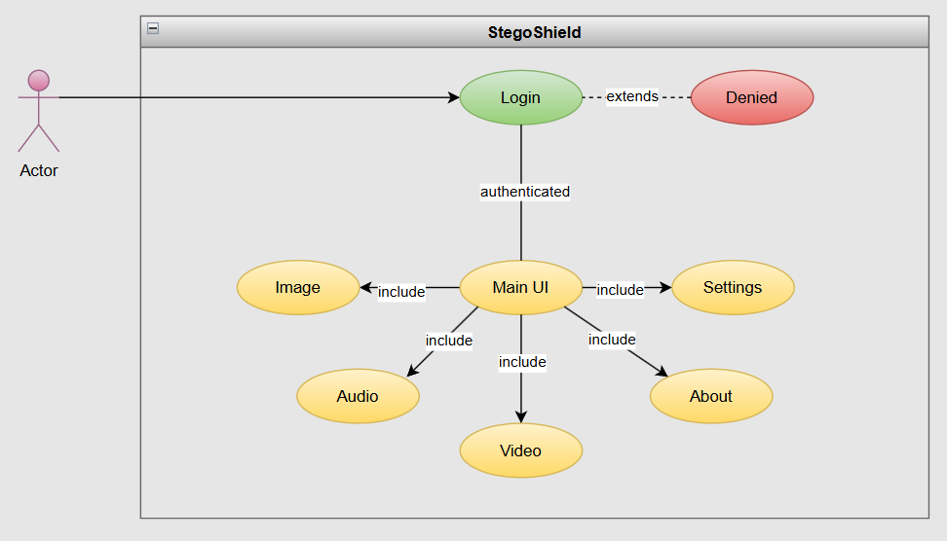
Figure 3.3.1 Use Case

3.4 Activity Diagram:

The Activity Diagram visualizes the flow of operations during message embedding and extraction, highlighting user decisions and system actions.

Embedding Activity:
- Begins with user authentication.
- Sequential steps guide the user to select media type, algorithm, encryption method, and file, ensuring necessary prerequisites are met before proceeding.
- The system validates inputs, encrypts the message (if selected), and performs embedding.
- Error handling is incorporated to manage invalid files, incorrect parameters, or insufficient media capacity.
- Concludes with output generation and user notification.

Extraction Activity:
- Follows a similar flow, starting from authentication.
- The user provides the stego file, algorithm, and decryption key (if required).
- System extracts the data, attempts decryption, and presents the result.
- Incorporates error handling for cases such as incorrect key, unsupported file, or file corruption.

This diagram ensures users are guided step-by-step and that the system maintains robustness through validation and feedback at each stage.

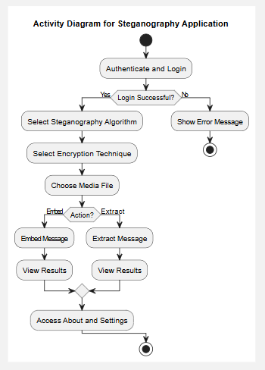
Figure 3.4.1 Activity Diagram

3.5 Sequence Diagram:

The Sequence Diagram details the chronological sequence of interactions between the system's components for both embedding and extraction processes:

Embedding Sequence:

1. User initiates the process via the UI, providing all required inputs.

2. UI collects inputs and passes them to the Business Logic layer.

3. Business Logic invokes the Encryption Module (if selected) to encrypt the message.

4. The (optionally) encrypted message is sent to the Stego Module, which embeds it into the cover media.

5. Stego Module returns the stego file to the Business Logic, which then updates the UI with results and saves the file.

6. UI provides completion feedback to the user.

Extraction Sequence:

1. User provides the stego file, algorithm, and key (if needed).

2. UI passes this to the Business Logic.

3. Business Logic directs the Stego Module to extract the hidden data.

4. Extracted data is sent to the Encryption Module for decryption if necessary.

5. Business Logic returns the result to the UI, which presents the original message to the user.

The sequence diagram clarifies the flow of information and ensures modules interact in an organized and predictable manner.

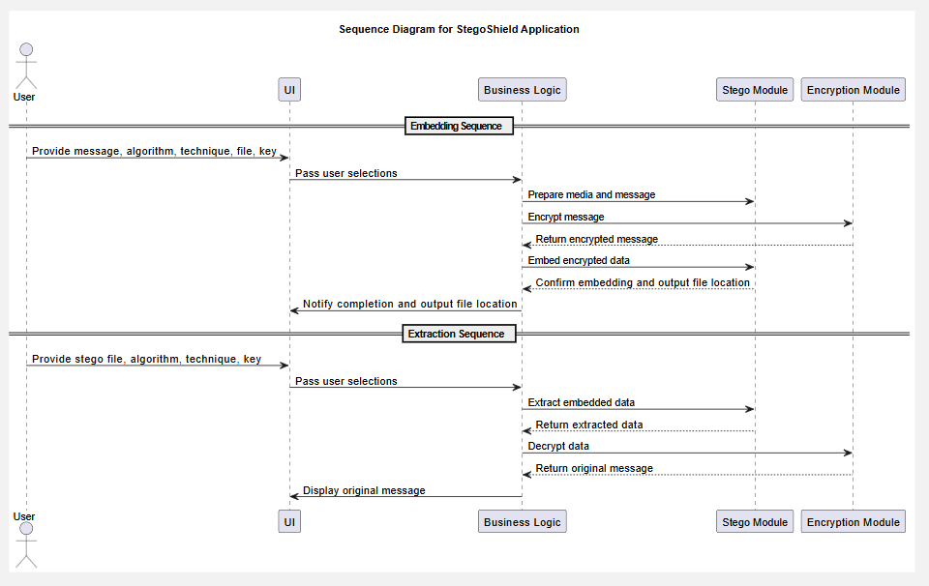
Figure 3.5.1 Sequence Diagram

3.6 Class Diagram:

The Class Diagram represents the static structure of StegoShield, showing classes, their attributes, methods, and relationships:

- StegoShieldApp: The central application class orchestrating the workflow, UI management, and system integration.

- Attributes: currentUser, settings, activeModules
- Methods: start(), handleEmbed(), handleExtract(), showResults(), etc.

- AuthDialog: Responsible for user authentication.

- Attributes: username, password
- Methods: authenticate(), showDialog()

- StegoModule (Abstract): Base class for all steganography algorithms.

- Methods: embed(), extract()
- Derived Classes: LSB, DCT, DWT, etc., each implementing specific algorithm logic.

- EncryptionModule (Abstract): Base for all encryption techniques.

- Methods: encrypt(), decrypt()
- Derived Classes: AES, DES, Blowfish, etc.

- Settings: Manages user and application preferences.

- Attributes: theme, defaultPaths, lastUsedAlgorithm
- Methods: load(), save(), update()

Relationships:
- `StegoShieldApp` composes/aggregates `AuthDialog`, `StegoModule`, `EncryptionModule`, and `Settings`.
- `StegoModule` and `EncryptionModule` are designed for polymorphic behavior, allowing runtime selection and extension.
- Each derived algorithm or technique class overrides base methods to provide specific implementations.
The class diagram ensures a scalable, maintainable, and easily extensible system, where new algorithms or features can be added with minimal impact on the existing codebase.

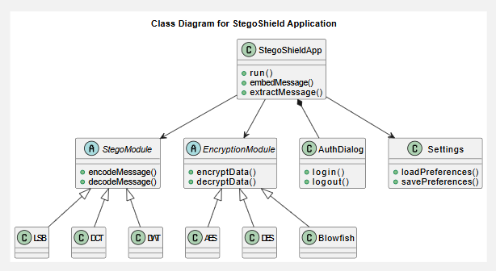
Figure 3.6.1 Class Diagram

4. Methodology, Implementation and Requirements.

4.1 Methodologies:

The development of StegoShield was guided by established software engineering principles to guarantee a high-quality, reliable, and user-friendly product. The project followed a modular and incremental development approach, where the system was broken down into manageable modules (e.g., GUI, steganography algorithms, encryption engine, file handling) that could be developed, tested, and integrated independently. Regular code reviews, continuous integration, and user feedback cycles were employed to improve code quality and usability. Agile practices such as iterative prototyping, sprint planning, and backlog grooming enabled the development team to adapt priorities and incorporate improvements based on stakeholder input throughout the project lifecycle.

4.2 SDLC Model Used

The Waterfall Model was initially chosen for clarity in requirements and sequential progress, but it was supplemented with Iterative Enhancement to address emerging requirements, fix bugs, and refine features. The following phases were carried out:

- Requirement Analysis: Defined all functionalities, use cases, and user interactions.

- System and Software Design: Created architectural diagrams, data flows, and module specifications.

- Implementation: Developed features module by module, starting with core functionality and then expanding to advanced features.

- Integration and Testing: Integrated modules and performed rigorous unit, integration, and system testing.

- Deployment: Released the software for end-user evaluation and feedback.

- Maintenance: Provided patches and enhancements based on user reports and changing requirements.

This combination allowed for both structured development and flexible adaptation to new insights.

4.3 Technologies Used

Figure 4.3.1 Technology Used

- Programming Language: Python 3.x
- User Interface: Tkinter (for cross-platform desktop GUI)
- Image Processing: PIL (Pillow)
- Audio Processing: wave, pydub
- Video Processing: OpenCV (cv2), numpy
- Encryption: PyCryptodome (AES, DES, Blowfish), hashlib for hashing
- File Handling: Python standard libraries (os, sys, shutil, pathlib)
- Testing: unittest, pytest, manual functional testing
- Version Control: git, GitHub
- Documentation: Markdown, Sphinx, draw.io for diagrams
- Packaging/Distribution: pyinstaller (for executable creation)

4.4 Hardware and Software Requirements

Hardware Requirements
- Processor: Minimum Intel/AMD Dual Core, recommended Quad Core or better
- RAM: 4 GB minimum, 8 GB or higher recommended
- Storage: 100 MB free disk space (more for handling large media files)
- Display: 1024x768 or higher for optimal GUI experience
- Optional: Sound card and speakers (for audio steganography)

Software Requirements
- OS: Windows 10/11, Ubuntu 20.04/22.04 LTS, macOS Monterey or later
- Python: 3.8 or higher
- Required Python Packages: Tkinter, Pillow, pydub, wave, OpenCV, PyCryptodome, numpy, etc.
- Development Tools: Visual Studio Code, PyCharm, or any Python IDE
- Other Tools: pip (package manager), git

4.5 Hardware and Software Used

Hardware Used

- Development Machine: Laptop with Intel Core i5/i7, 8–16 GB RAM, 256–512 GB SSD

- Testing Machines:Additional desktops/laptops with varying specs for cross-platform testing

Software Used

- Operating Systems: Windows 11, Ubuntu 22.04 LTS, macOS Ventura

- Python Version: 3.11.x

- IDEs/Text Editors: Visual Studio Code, PyCharm Community, Atom

- Version Control: git (local and remote via GitHub)

- Libraries/Frameworks: As detailed above

- Utilities: pyinstaller (for building standalone executables), draw.io (diagramming), Markdown editors (for documentation)

4.6 Standard Followed:

- Coding Standards: Python PEP 8 for code format and readability; consistent naming conventions and modularization
- Documentation: Comprehensive inline comments, docstrings for all functions/classes, external documentation in Markdown and Sphinx (where applicable)
- Testing: Adherence to unit testing principles, automated test scripts for critical modules, manual and automated GUI testing
- Security: Use of established, well-maintained cryptographic libraries; secure key handling; avoidance of deprecated/insecure algorithms
- User Interface: Compliance with common desktop application design guidelines for usability and accessibility; clear labeling, tooltips, and error/success notifications
- Software Engineering: Separation of concerns, DRY (Don't Repeat Yourself) principle, reusability, maintainability, and scalability
- Version Control: Regular commits with clear messages, use of feature branches, pull requests and code review on GitHub

5 DETAILED LIFE CYCLE OF THE PROJECT
5.1 ER Diagram

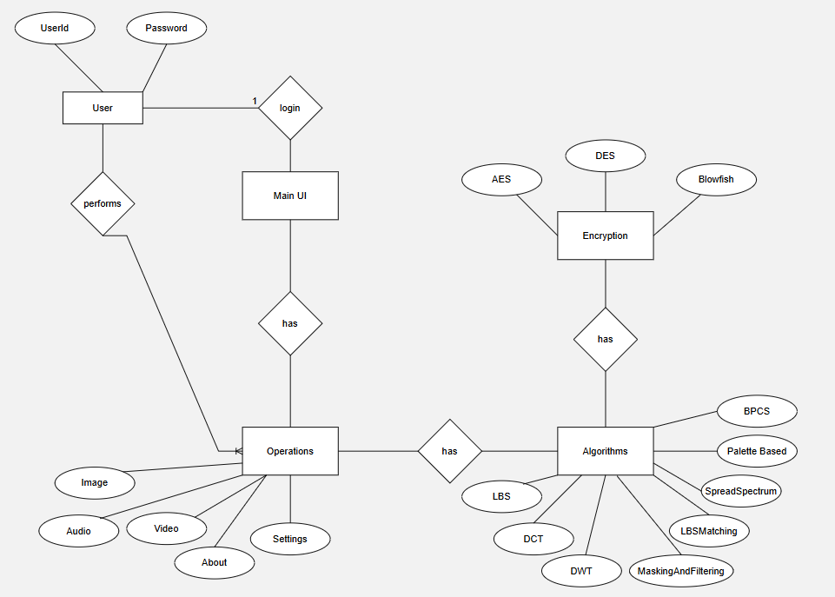
Figure 5.1 .1 ER Diagram
Explanation:

Entities & Attributes:
User

-Attributes: UserId, Password.

-This entity represents the users who log into your application.

Main UI

-This isn’t a typical ER entity — it acts more like a control point or interface entity in your diagram.

-It's involved when the User logs in and accesses features.

Operations

-Represents the available actions or modules in your application.

-Related to different operation types a user can perform.

Encryption

-Represents the encryption module of your app.

-Encryption Techniques: AES, DES, Blowfish (as attributes connected via relationships)

Algorithms

-Refers to the steganography techniques your app supports.

-Techniques listed: LSB, DCT, DWT, MaskingAndFiltering, LBMatching, SpreadSpectrum, PaletteBased, BPCS

Relationships:

User — login → Main UI

-1:1 relationship

-A user logs into the system through the UI.

User — performs → Operations

-A User can perform multiple Operations (Embed, Extract, Settings, About, etc.)

-Attributes connected to Operations: Image, Audio, Video, Settings, About (representing modules/features available under Operations)

Main UI — has → Operations

-The UI offers various operation options for the user to interact with, like encrypting data or embedding messages.

Encryption — has → AES / DES / Blowfish

-Encryption module contains multiple algorithms (as sub-entities/attributes)

-When embedding or extracting, the chosen encryption method is applied.

Operations — has → Algorithms

-Operations depend on Algorithms for steganography tasks
-Supported algorithms are connected as attributes to the Algorithms entity.

Summary

The ER diagram models how a user interacts with the application:
-Logs in through a UI
-Performs operations (like embedding messages, extracting data, managing settings)
-Chooses from a variety of encryption algorithms
-Utilizes different steganography algorithms during operations

5.2 DFD Diagram

Level 0: High-level interaction between user and system.

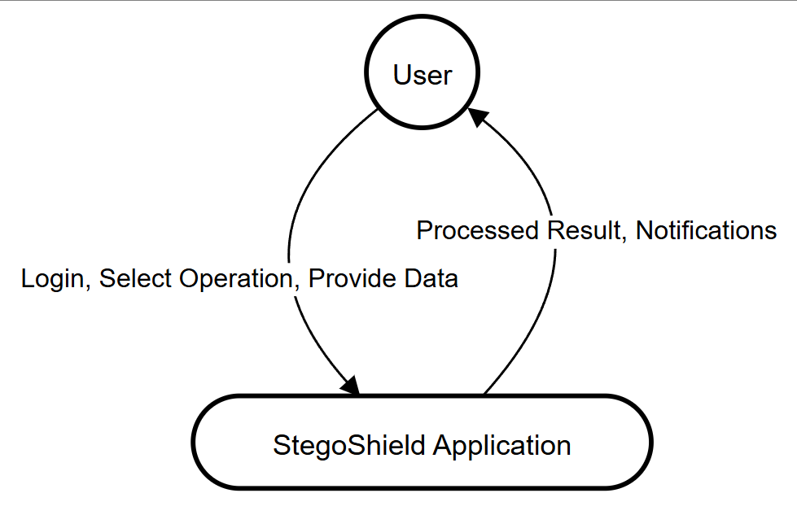
Figure 5.2 .1 DFD Level 0

DFD Level 1: Break down system into major modules: UI, Encryption, Stego Algorithms, Operations.

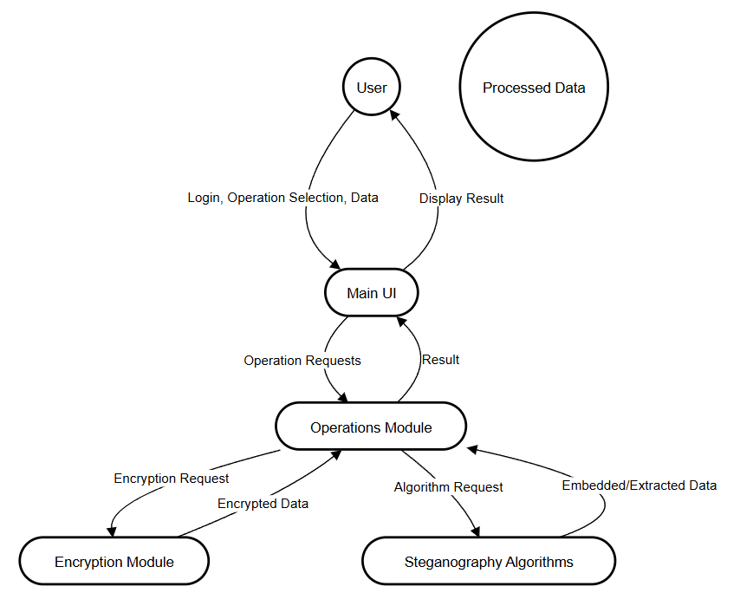
Figure 5.2 .2 DFD Level 1

DFD Level 2: Drilling into Operations: how it works internally with specific techniques

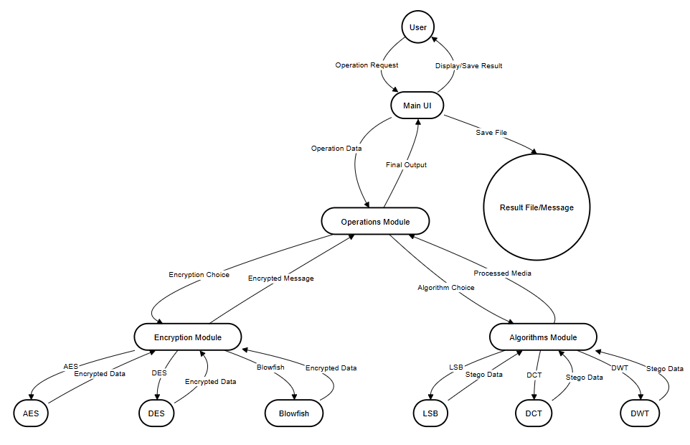
Figure 5.2 .3 DFD Level 2

5.3 Methodology Used Testing

A thorough, multi-layered testing methodology was adopted to ensure robust, secure, and reliable software:
- Unit Testing: Each functional component (e.g., encryption module, steganography algorithms, file handler) was tested in isolation with automated scripts using Python’s `unittest` and `pytest`.
- Integration Testing: Modules were combined and tested for correct interaction and data flow, ensuring that encryption, embedding, and extraction work seamlessly together.
- System Testing: The entire application was tested as a whole to validate end-to-end scenarios such as a complete embed-extract cycle, error reporting, and user authentication.
- Regression Testing: Automated and manual tests were periodically run after major changes to ensure that bug fixes and new features did not introduce new issues.
- Security Testing: Special focus was placed on the safe handling of sensitive data (e.g., encryption keys, user messages), protection against unauthorized access, and avoidance of insecure libraries or deprecated algorithms.
- User Acceptance Testing (UAT): Real users tested the application for usability, clarity, and reliability. Feedback was used to refine the interface and workflows.
- Performance and Stress Testing: Large media files and high-frequency operations were tested to ensure the application's responsiveness and stability under load.

5.4 Testing

TC No. | Test Case Description | Input Data | Expected Result | Status
TC01 | Validate user login with correct credentials | Valid UserID, Password | Login Successful | Pass
TC02 | Validate user login with invalid credentials | Invalid UserID, Password | Login Failed Message | Pass
TC03 | Check access to Main UI after login | Valid User session | Main UI Loads | Pass
TC04 | Select and perform an Embed operation | Image file, message, algorithm, encryption, key | Embedding completed, stego file generated | Pass
TC05 | Select and perform an Extract operation | Stego file, algorithm, decryption key | Original message displayed | Pass
TC06 | Validate encryption using AES | Message, AES key | Encrypted message returned | Pass
TC07 | Validate encryption using DES | Message, DES key | Encrypted message returned | Pass
TC08 | Validate encryption using Blowfish | Message, Blowfish key | Encrypted message returned | Pass
TC09 | Check LSB embedding operation | Image file, encrypted message | Stego image generated | Pass
TC10 | Check DCT embedding operation | Image file, encrypted message | Stego image generated | Pass
TC11 | Check DWT embedding operation | Image file, encrypted message | Stego image generated | Pass
TC12 | Verify decryption of AES-encrypted message | Encrypted message, AES key | Original message retrieved | Pass
TC13 | Validate error on invalid encryption key | Encrypted message, wrong key | Decryption error message | Pass
TC14 | Check supported file types for embedding | Image, Audio, Video files | Operation proceeds only with supported types | Pass
TC15 | Check system handling of unsupported file types | PDF, DOCX | Error message shown | Pass
TC16 | Validate system handling of missing inputs | No file, message, or key | Error prompt to enter required fields | Pass
TC17 | Test concurrent user sessions | Multiple users logging in simultaneously | No session conflicts or data mix | Pass
TC18 | Validate operations history logging | Successful embed/extract operation | Record saved to history log | Pass
TC19 | Check user settings save & load | User preferences set & reloaded | Correct preferences loaded | Pass
TC20 | Validate stego file path generation | On embedding operation | Correct path generated and file saved | Pass
TC21 | Test extraction with incorrect stego file | Corrupted or wrong file | Error message and no data extracted | Pass
TC22 | Verify processing time for large files | Large image/audio/video files | Operation completes within acceptable time | Pass
TC23 | Check system logs for successful operations | Perform embedding/extract | Entry logged with timestamp & status | Pass
TC24 | Validate selection of algorithms dynamically | Choose any from LSB, DCT, DWT | Operation uses selected algorithm | Pass
TC25 | Test operation cancellation midway | Mid-operation cancel request | Operation halts, no output generated | Pass
TC No. | Test Case Description | Input Data | Expected Result | Status
TC26 | Validate encryption with empty message | Empty message, valid key | Error prompt for message input | Pass
TC27 | Attempt embedding without selecting a file | Message, no file selected | Error prompt to select a file | Pass
TC28 | Attempt extraction without selecting algorithm | Stego file, no algorithm | Error prompt to select algorithm | Pass
TC29 | Attempt extraction without providing key | Stego file, no decryption key | Error prompt to enter key | Pass
TC30 | Validate login session timeout | Inactive user for defined period | Auto logout and return to login screen | Pass
TC31 | Validate long password handling | Very long password string | Successful login or proper error handling | Pass
TC32 | Attempt to use unsupported encryption technique | Custom/unsupported technique | Error message: Not supported | Pass
TC33 | Check file overwriting prevention | Output file with same name exists | Prompt to rename or overwrite | Pass
TC34 | Validate result file path display in UI | Successful operation | Display correct file path | Pass
TC35 | Attempt to decrypt already decrypted message | Decrypted message, key | Error: message not encrypted | Pass
TC36 | Validate settings save persistence after app restart | Set preferences, restart app | Preferences retained | Pass
TC37 | Validate cancel operation during encryption | User triggers cancel | Encryption process aborted safely | Pass
TC38 | Validate cancel operation during embedding | User triggers cancel | Embedding process aborted safely | Pass
TC39 | Check error handling for corrupted image files | Corrupt image file | Error message displayed | Pass
TC40 | Test multi-language message embedding | Message in Hindi, Japanese, Arabic | Successful embedding and extraction | Pass
TC41 | Validate empty preferences save | No settings input | Default values used | Pass
TC42 | Validate concurrent embedding and extraction | Two parallel operations | No data conflict or crash | Pass
TC43 | Check database logging of failed operations | Failed embed/extract operation | Operation history recorded as 'Failed' | Pass
TC44 | Validate export of operation logs | Request to export logs | CSV/JSON file generated with logs | Pass
TC45 | Check system behavior on low disk space | Large output file with insufficient storage | Error message: No space available | Pass
TC46 | Test encryption with special character key | Key with @#$%&* characters | Encryption works or error message | Pass
TC47 | Validate invalid file extension handling | Unsupported extension (e.g., .exe) | Error message shown | Pass
TC48 | Attempt embedding into a read-only file | Read-only image file | Error message: Cannot write to file | Pass
TC49 | Validate password hashing and verification | Password storage | Secure hash stored, correct login verification | Pass
TC50 | Check audit log integrity on unauthorized access attempt | Login attempt with wrong credentials | Audit log entry created | Pass

6. CODING AND SCREENSHOTS
6.1 Coding Layout

StegoShield.py

import tkinter as tk
from tkinter import ttk, filedialog, messagebox, StringVar, Text
import importlib
import os
import about.about as about
from settings import settings as settings_tab # <-- Import settings tab
from auth_window import AuthDialog # <-- Import authentication window

# --- Dynamic Imports for Stego Algorithms and Encryption Techniques ---
STEGO_ALGO_DIR = "stego_algorithms"
ENCRYPTION_DIR = "encryption_techniques"

# Supported algorithms for each type
STEGO_ALGOS = {
"Image": ["LSB", "MaskingAndFiltering", "DCT", "DWT", "LSBMatching", "SpreadSpectrum", "PaletteBased", "BPCS"],
"Audio": ["LSB", "DWT", "SpreadSpectrum", "LSBMatching"],
"Video": ["LSB", "DCT", "DWT", "SpreadSpectrum"]
}

ENCRYPTION_TECHS = ["AES", "DES", "Blowfish"]

# Modes for each encryption technique
ENCRYPTION_MODES = {
"AES": ["ECB", "CBC", "CFB", "OFB"],
"DES": ["ECB", "CBC", "CFB", "OFB"],
"Blowfish": ["ECB", "CBC", "CFB", "OFB"]
}

def import_stego_algo(algo):
module = importlib.import_module(f"{STEGO_ALGO_DIR}.{algo}")
return module

def import_encryption_tech(tech):
module = importlib.import_module(f"{ENCRYPTION_DIR}.{tech}")
return module

# --- Logic for encryption and decryption ---

def handle_encrypt(tab_type, algo, tech, mode, message, key, cover_path):
try:
enc_module = import_encryption_tech(tech)
# Always encode message to bytes before encrypting
encrypted = enc_module.encrypt(message.encode('utf-8'), key, mode)
stego_module = import_stego_algo(algo)
output_path = stego_module.encode(cover_path, encrypted)
return f"Success. Output file: {output_path}"
except Exception as e:
return f"Encryption/Embedding error: {str(e)}"

def handle_decrypt(tab_type, algo, tech, mode, key, stego_path):
try:
stego_module = import_stego_algo(algo)
extracted = stego_module.decode(stego_path)
enc_module = import_encryption_tech(tech)
decrypted_bytes = enc_module.decrypt(extracted, key, mode)
decrypted_text = decrypted_bytes.decode('utf-8')
return decrypted_text
except Exception as e:
return f"Decryption/Extraction error: {str(e)}"

# --- UI Definitions ---

def add_watermark(parent):
watermark = tk.Label(parent, text="@2025 SegoShield App by Vivek Kumar Yadav",
font=("Arial", 11, "italic"), fg="gray70")
watermark.pack(side="bottom", fill="x", pady=3) # fill X to always stay at bottom
return watermark

class StegoShieldApp(tk.Tk):
def __init__(self):
super().__init__()
self.title("StegoShield")
self.geometry("1100x700")
self.resizable(False, False)
self.init_ui()

def init_ui(self):
tab_control = ttk.Notebook(self)
tabs = {}

# Image, Audio, Video tabs
for tab_type in ["Image", "Audio", "Video"]:
tab = tk.Frame(tab_control) # Use tk.Frame for easier packing
tab_control.add(tab, text=tab_type)
self.build_encrypt_decrypt_tab(tab, tab_type)
add_watermark(tab)
tabs[tab_type] = tab

# About tab (NO WATERMARK)
about_tab = tk.Frame(tab_control)
tab_control.add(about_tab, text="About")
about.about_tab_content(about_tab)
# DO NOT CALL add_watermark(about_tab)

# Settings tab
settings_tab_frame = tk.Frame(tab_control)
tab_control.add(settings_tab_frame, text="Settings")
settings_tab.settings_tab_content(settings_tab_frame)
add_watermark(settings_tab_frame)

tab_control.pack(expand=1, fill="both")

def build_encrypt_decrypt_tab(self, parent, tab_type):
frame = ttk.Frame(parent)
frame.pack(fill="both", expand=True, padx=10, pady=10)

enc_box = ttk.LabelFrame(frame, text="Encryption", width=500, height=600)
dec_box = ttk.LabelFrame(frame, text="Decryption", width=500, height=600)
enc_box.place(x=10, y=10, width=520, height=650)
dec_box.place(x=570, y=10, width=520, height=650)

# --- Encryption Box ---
ttk.Label(enc_box, text="1. Encryption Algorithm").pack(anchor="w", padx=10, pady=(10,0))
enc_algo_var = StringVar(value=STEGO_ALGOS[tab_type][0])
enc_algo_box = ttk.Combobox(enc_box, textvariable=enc_algo_var, state="readonly", values=STEGO_ALGOS[tab_type])
enc_algo_box.pack(anchor="w", padx=20, pady=2)

ttk.Label(enc_box, text="2. Encryption Technique").pack(anchor="w", padx=10)
enc_tech_var = StringVar(value=ENCRYPTION_TECHS[0])
enc_tech_box = ttk.Combobox(enc_box, textvariable=enc_tech_var, state="readonly", values=ENCRYPTION_TECHS)
enc_tech_box.pack(anchor="w", padx=20, pady=2)

ttk.Label(enc_box, text="3. Modes").pack(anchor="w", padx=10)
enc_mode_var = StringVar(value=ENCRYPTION_MODES[ENCRYPTION_TECHS[0]][0])
enc_mode_box = ttk.Combobox(enc_box, textvariable=enc_mode_var, state="readonly", values=ENCRYPTION_MODES[ENCRYPTION_TECHS[0]])
enc_mode_box.pack(anchor="w", padx=20, pady=2)

def update_modes(*args):
tech = enc_tech_var.get()
enc_mode_box["values"] = ENCRYPTION_MODES.get(tech, ["ECB"])
enc_mode_var.set(ENCRYPTION_MODES.get(tech, ["ECB"])[0])
enc_tech_var.trace("w", update_modes)

ttk.Label(enc_box, text="4. Enter Message to Encrypt").pack(anchor="w", padx=10)
enc_message = Text(enc_box, height=4, width=48)
enc_message.pack(anchor="w", padx=20, pady=2)

ttk.Label(enc_box, text="5. Encryption Key").pack(anchor="w", padx=10)
enc_key_var = StringVar()
enc_key_entry = ttk.Entry(enc_box, textvariable=enc_key_var, width=35, show="*")
enc_key_entry.pack(anchor="w", padx=20, pady=2)

ttk.Label(enc_box, text="6. Select Cover File").pack(anchor="w", padx=10)
enc_file_var = StringVar()
def browse_enc_file():
if tab_type == "Image":
types = [("Image Files", "*.png *.bmp *.jpg *.jpeg"), ("All Files", "*.*")]
elif tab_type == "Audio":
types = [("Audio Files", "*.wav *.mp3"), ("All Files", "*.*")]
else: # Video
types = [("Video Files", "*.mp4 *.avi *.mov *.mkv"), ("All Files", "*.*")]
filename = filedialog.askopenfilename(title="Select Cover File", filetypes=types)
if filename: enc_file_var.set(filename)
ttk.Button(enc_box, text="Browse", command=browse_enc_file).pack(anchor="w", padx=20, pady=2)
ttk.Label(enc_box, textvariable=enc_file_var, foreground="blue").pack(anchor="w", padx=20, pady=2)

# Encryption action result
enc_result_var = StringVar()
ttk.Label(enc_box, textvariable=enc_result_var, foreground="green").pack(anchor="w", padx=20, pady=2)

def run_encrypt():
# Get values
algo = enc_algo_var.get()
tech = enc_tech_var.get()
mode = enc_mode_var.get()
message = enc_message.get("1.0", "end-1c")
key = enc_key_var.get()
file_path = enc_file_var.get()
if not (algo and tech and mode and message and key and file_path):
enc_result_var.set("Please fill all fields and select a file.")
return
result = handle_encrypt(tab_type, algo, tech, mode, message, key, file_path)
enc_result_var.set(result)

ttk.Button(enc_box, text="Encrypt & Embed", command=run_encrypt).pack(pady=12)

# --- Decryption Box ---
ttk.Label(dec_box, text="1. Select Stego File").pack(anchor="w", padx=10, pady=(10,0))
dec_file_var = StringVar()
def browse_dec_file():
if tab_type == "Image":
types = [("Image Files", "*.png *.bmp *.jpg *.jpeg"), ("All Files", "*.*")]
elif tab_type == "Audio":
types = [("Audio Files", "*.wav *.mp3"), ("All Files", "*.*")]
else:
types = [("Video Files", "*.mp4 *.avi *.mov *.mkv"), ("All Files", "*.*")]
filename = filedialog.askopenfilename(title="Select Stego File", filetypes=types)
if filename: dec_file_var.set(filename)
ttk.Button(dec_box, text="Browse", command=browse_dec_file).pack(anchor="w", padx=20, pady=2)
ttk.Label(dec_box, textvariable=dec_file_var, foreground="blue").pack(anchor="w", padx=20, pady=2)

ttk.Label(dec_box, text="2. Decryption Algorithm").pack(anchor="w", padx=10)
dec_algo_var = StringVar(value=STEGO_ALGOS[tab_type][0])
dec_algo_box = ttk.Combobox(dec_box, textvariable=dec_algo_var, state="readonly", values=STEGO_ALGOS[tab_type])
dec_algo_box.pack(anchor="w", padx=20, pady=2)

ttk.Label(dec_box, text="3. Decryption Technique").pack(anchor="w", padx=10)
dec_tech_var = StringVar(value=ENCRYPTION_TECHS[0])
dec_tech_box = ttk.Combobox(dec_box, textvariable=dec_tech_var, state="readonly", values=ENCRYPTION_TECHS)
dec_tech_box.pack(anchor="w", padx=20, pady=2)

ttk.Label(dec_box, text="4. Modes").pack(anchor="w", padx=10)
dec_mode_var = StringVar(value=ENCRYPTION_MODES[ENCRYPTION_TECHS[0]][0])
dec_mode_box = ttk.Combobox(dec_box, textvariable=dec_mode_var, state="readonly", values=ENCRYPTION_MODES[ENCRYPTION_TECHS[0]])
dec_mode_box.pack(anchor="w", padx=20, pady=2)

def update_dec_modes(*args):
tech = dec_tech_var.get()
dec_mode_box["values"] = ENCRYPTION_MODES.get(tech, ["ECB"])
dec_mode_var.set(ENCRYPTION_MODES.get(tech, ["ECB"])[0])
dec_tech_var.trace("w", update_dec_modes)

ttk.Label(dec_box, text="5. Decryption Key").pack(anchor="w", padx=10)
dec_key_var = StringVar()
dec_key_entry = ttk.Entry(dec_box, textvariable=dec_key_var, width=35, show="*")
dec_key_entry.pack(anchor="w", padx=20, pady=2)

ttk.Label(dec_box, text="6. Decrypted Message").pack(anchor="w", padx=10)
dec_message = Text(dec_box, height=4, width=48, state="normal")
dec_message.pack(anchor="w", padx=20, pady=2)

dec_result_var = StringVar()
ttk.Label(dec_box, textvariable=dec_result_var, foreground="green").pack(anchor="w", padx=20, pady=2)

def run_decrypt():
algo = dec_algo_var.get()
tech = dec_tech_var.get()
mode = dec_mode_var.get()
key = dec_key_var.get()
file_path = dec_file_var.get()
if not (algo and tech and mode and key and file_path):
dec_result_var.set("Please fill all fields and select a file.")
return
result = handle_decrypt(tab_type, algo, tech, mode, key, file_path)
dec_message.config(state="normal")
dec_message.delete("1.0", "end")
dec_message.insert("1.0", result)
dec_message.config(state="disabled")
if not result.startswith("Decryption/Extraction error"):
dec_result_var.set("Decryption successful.")
else:
dec_result_var.set(result)

ttk.Button(dec_box, text="Extract & Decrypt", command=run_decrypt).pack(pady=12)

if __name__ == "__main__":
# AUTHENTICATION WINDOW (before main UI)
root = tk.Tk()
root.withdraw() # Hide root while authenticating
auth = AuthDialog(root)
if auth.result is not None:
root.destroy()
if not os.path.isdir(STEGO_ALGO_DIR) or not os.path.isdir(ENCRYPTION_DIR):
messagebox.showerror("Missing Modules", f"Required folders '{STEGO_ALGO_DIR}' and/or '{ENCRYPTION_DIR}' not found.\nPlease ensure all algorithm modules are placed correctly.")
else:
app = StegoShieldApp()
app.mainloop()
else:
root.destroy()

auth_window.py

import tkinter as tk
from tkinter import simpledialog, messagebox
import json
import os

AUTH_FILE = os.path.join(os.path.dirname(__file__), "settings", "auth.json")

def ensure_default_auth():
if not os.path.exists(AUTH_FILE):
os.makedirs(os.path.dirname(AUTH_FILE), exist_ok=True)
with open(AUTH_FILE, "w") as f:
json.dump({"username": "admin", "password": "admin"}, f, indent=2)

def load_auth():
ensure_default_auth()
with open(AUTH_FILE) as f:
return json.load(f)

def save_auth(username, password):
os.makedirs(os.path.dirname(AUTH_FILE), exist_ok=True)
with open(AUTH_FILE, "w") as f:
json.dump({"username": username, "password": password}, f, indent=2)

class AuthDialog(simpledialog.Dialog):
def __init__(self, parent):
self.username_var = tk.StringVar()
self.password_var = tk.StringVar()
super().__init__(parent, "StegoShield Login")

def show_centered(self, w=800, h=500):
# Center the dialog on the screen
self.update_idletasks()
sw = self.winfo_screenwidth()
sh = self.winfo_screenheight()
x = (sw - w) // 2
y = (sh - h) // 2
self.geometry(f"{w}x{h}+{x}+{y}")

def body(self, master):
self.show_centered(800, 500)
font_box = ("Arial", 18, "bold")
font_label = ("Arial", 14)
font_entry = ("Arial", 14)

# Outer frame for centering
outer = tk.Frame(master)
outer.pack(expand=True, fill="both")

# Centered, smaller login box
box = tk.LabelFrame(outer, text="Login", font=font_box, padx=28, pady=20, labelanchor='n')
box.pack(expand=True)
tk.Label(box, text="Username:", font=font_label).grid(row=0, column=0, sticky="e", padx=18, pady=12)
self.user_entry = tk.Entry(box, textvariable=self.username_var, font=font_entry, width=18)
self.user_entry.grid(row=0, column=1, pady=12, padx=12)
tk.Label(box, text="Password:", font=font_label).grid(row=1, column=0, sticky="e", padx=18, pady=12)
self.pass_entry = tk.Entry(box, textvariable=self.password_var, show="*", font=font_entry, width=18)
self.pass_entry.grid(row=1, column=1, pady=12, padx=12)

# Buttons for Enter and Reset (smaller)
button_frame = tk.Frame(outer)
button_frame.pack(pady=5)
enter_btn = tk.Button(button_frame, text="Enter", font=("Arial", 12), width=10, command=self.ok, default=tk.ACTIVE)
enter_btn.grid(row=0, column=0, padx=10, pady=6)
reset_btn = tk.Button(button_frame, text="Reset", font=("Arial", 12), width=10, command=self.reset_fields)
reset_btn.grid(row=0, column=1, padx=10, pady=6)
self.bind("<Return>", lambda event: self.ok())
self.bind("<Escape>", lambda event: self.reset_fields())

# Watermark
watermark = tk.Label(outer, text="@2025 SegoShield App by Vivek Kumar Yadav",
font=("Arial", 17, "italic"), fg="gray70")
watermark.pack(side="bottom", pady=8)

return self.user_entry # For initial focus

def reset_fields(self):
self.username_var.set("")
self.password_var.set("")
self.user_entry.focus_set()

def buttonbox(self):
pass # Buttons handled above

def validate(self):
creds = load_auth()
username = self.username_var.get().strip()
password = self.password_var.get().strip()
if username == creds["username"] and password == creds["password"]:
return True
messagebox.showerror("Authentication Failed", "Invalid username or password.")
return False

def apply(self):
self.result = self.username_var.get()

about.py

import tkinter as tk
from tkinter import ttk
import json
import os
import matplotlib
matplotlib.use("TkAgg")
from matplotlib.backends.backend_tkagg import FigureCanvasTkAgg
from matplotlib.figure import Figure

DATA_FILE = os.path.join(os.path.dirname(__file__), "algo_benchmark.json")

def load_algo_benchmark():
if not os.path.exists(DATA_FILE):
default = [
{"algorithm": "LSB", "time_ms": 120},
{"algorithm": "MaskingAndFiltering", "time_ms": 150},
{"algorithm": "DCT", "time_ms": 200},
{"algorithm": "DWT", "time_ms": 210},
{"algorithm": "LSBMatching", "time_ms": 160},
{"algorithm": "SpreadSpectrum", "time_ms": 250},
{"algorithm": "PaletteBased", "time_ms": 180},
{"algorithm": "BPCS", "time_ms": 300}
]
with open(DATA_FILE, "w") as f:
json.dump(default, f, indent=2)
return default
with open(DATA_FILE) as f:
return json.load(f)

def save_algo_benchmark(data):
with open(DATA_FILE, "w") as f:
json.dump(data, f, indent=2)

def add_algo_time(algorithm, time_ms):
data = load_algo_benchmark()
for row in data:
if row["algorithm"] == algorithm:
row["time_ms"] = time_ms
break
else:
data.append({"algorithm": algorithm, "time_ms": time_ms})
save_algo_benchmark(data)

def about_tab_content(parent):
# --- SCROLLABLE FRAME SETUP ---
canvas = tk.Canvas(parent, borderwidth=0, highlightthickness=0)
vscroll = tk.Scrollbar(parent, orient="vertical", command=canvas.yview)
canvas.configure(yscrollcommand=vscroll.set)
vscroll.pack(side="right", fill="y")
canvas.pack(side="left", fill="both", expand=True)

content_frame = tk.Frame(canvas)
window_id = canvas.create_window((0, 0), window=content_frame, anchor="nw")

def on_configure(event):
canvas.configure(scrollregion=canvas.bbox("all"))
canvas.itemconfig(window_id, width=canvas.winfo_width())
content_frame.bind("<Configure>", on_configure)
canvas.bind("<Configure>", lambda event: canvas.itemconfig(window_id, width=canvas.winfo_width()))

def _on_mousewheel(event):
canvas.yview_scroll(int(-1*(event.delta/120)), "units")
content_frame.bind_all("<MouseWheel>", _on_mousewheel)
content_frame.bind_all("<Button-4>", lambda event: canvas.yview_scroll(-1, "units"))
content_frame.bind_all("<Button-5>", lambda event: canvas.yview_scroll(1, "units"))

# --- ACTUAL CONTENT BELOW ---
title = tk.Label(content_frame, text="About StegoShield", font=("Arial", 20, "bold"))
title.pack(pady=(10, 3))

txt = (
"StegoShield is a secure steganography toolkit for educational and research purposes. It allows users to hide secret messages in images, audio, or video using robust steganographic and cryptographic algorithms, "
"making confidential communication simple and effective.\n\n"
"Target User: Anyone needing to transmit confidential information stealthily, such as:\n"
"- Students & educators (education/demonstration)\n"
"- Journalists in sensitive contexts\n"
"- Whistleblowers\n"
"- Security researchers\n"
"- Privacy-conscious users\n\n"
"Educational Purpose: StegoShield is also designed as a learning tool for students, educators, and enthusiasts to explore and understand a wide variety of steganography and encryption techniques in a hands-on manner."
)
tk.Label(content_frame, text=txt, wraplength=950, justify="left", font=("Arial", 11)).pack(anchor="w", padx=12, pady=(0,7))

tk.Label(content_frame, text="Steganography Algorithms Used:", font=("Arial", 12, "bold")).pack(anchor="w", padx=12)
stego_points = [
"• LSB (Least Significant Bit): Hides message bits in the least significant bits of image/audio samples. Simple and fast, but vulnerable to detection.",
"• Masking & Filtering: Embeds information in significant areas of the cover, like image masks, robust to some image manipulations.",
"• DCT (Discrete Cosine Transform): Hides data in frequency components of images (used in JPEG), more robust against compression.",
"• DWT (Discrete Wavelet Transform): Embeds message in wavelet coefficients, robust and used for watermarking.",
"• LSB Matching: A variation of LSB that randomly increases or decreases pixel value, making detection harder.",
"• Spread Spectrum: Spreads the message across the cover object using pseudo-noise, robust to noise and cropping.",
"• Palette Based: Alters the palette of images (like GIF), used for hiding data without altering visible pixels.",
"• BPCS (Bit-Plane Complexity Segmentation): Hides data in complex areas of an image, high capacity, robust against analysis."
]
for point in stego_points:
tk.Label(content_frame, text=point, wraplength=950, justify="left", font=("Arial", 10)).pack(anchor="w", padx=24)

tk.Label(content_frame, text="Encryption Techniques and Modes:", font=("Arial", 12, "bold")).pack(anchor="w", padx=12, pady=(10,0))
enc_points = [
"• AES (Advanced Encryption Standard): Strong symmetric cipher, industry standard, supports 128/192/256 bit keys.",
"• DES (Data Encryption Standard): Classic cipher, fast but less secure due to small key size.",
"• Blowfish: Fast, flexible block cipher, good for embedded systems and general use.",
"Encryption Modes:",
" - ECB (Electronic Codebook): Each block encrypted independently. Fast, but not recommended for patterns.",
" - CBC (Cipher Block Chaining): Each block XORed with previous ciphertext, more secure.",
" - CFB (Cipher Feedback): Converts block cipher into self-synchronizing stream cipher.",
" - OFB (Output Feedback): Turns block cipher into synchronous stream cipher, errors do not propagate."
]
for point in enc_points:
tk.Label(content_frame, text=point, wraplength=950, justify="left", font=("Arial", 10)).pack(anchor="w", padx=24)

tk.Label(content_frame, text="Algorithm & Encryption Technique Comparison:", font=("Arial", 12, "bold")).pack(anchor="w", padx=12, pady=(10,0))
table_frame = tk.Frame(content_frame)
table_frame.pack(anchor='w', padx=22)
header = ["Name", "Pros", "Cons"]
rows = [
["LSB", "Simple, fast, high capacity", "Not robust, easy to detect, susceptible to image edits"],
["MaskingAndFiltering", "Robust against compression", "Low capacity, only for images"],
["DCT", "Robust against compression, used in JPEG", "Complex, possible quality loss"],
["DWT", "High robustness and capacity", "Higher computational cost"],
["LSBMatching", "Harder to detect than LSB", "Still vulnerable to steganalysis"],
["SpreadSpectrum", "Very robust to attacks", "Low capacity, complex"],
["PaletteBased", "No visual change", "Limited to palette images"],
["BPCS", "High capacity, robust", "Complex, may cause visible change"],
["AES", "Highly secure, widely trusted", "Slower, needs strong key management"],
["DES", "Fast, simple", "Weak security, deprecated for new systems"],
["Blowfish", "Very fast, flexible key length", "Not standardized, not for very large data"]
]
for j, col in enumerate(header):
tk.Label(table_frame, text=col, font=("Arial", 10, "bold"), borderwidth=1, relief="solid", width=23).grid(row=0, column=j)
for i, row in enumerate(rows):
for j, val in enumerate(row):
tk.Label(table_frame, text=val, font=("Arial", 10), borderwidth=1, relief="solid", wraplength=230, justify="left").grid(row=i+1, column=j, sticky="w")

tk.Label(content_frame, text="Realtime Steganography Algorithm Processing Time (ms):", font=("Arial", 12, "bold")).pack(anchor="w", padx=12, pady=(15,0))
chart_frame = tk.Frame(content_frame)
chart_frame.pack(fill='both', expand=False, padx=30, pady=10)

def refresh_chart():
for widget in chart_frame.winfo_children():
widget.destroy()
_draw_chart(chart_frame)

refresh_btn = tk.Button(content_frame, text="Refresh Chart", command=refresh_chart)
refresh_btn.pack(anchor="e", padx=30, pady=5)

_draw_chart(chart_frame)

def _draw_chart(frame):
data = load_algo_benchmark()
algo_names = [
"LSB", "MaskingAndFiltering", "DCT", "DWT",
"LSBMatching", "SpreadSpectrum", "PaletteBased", "BPCS"
]
filtered = [row for row in data if row["algorithm"] in algo_names]
algos = [row["algorithm"] for row in filtered]
times = [row["time_ms"] for row in filtered]
fig = Figure(figsize=(10, 4.5), dpi=100) # less wide, higher
ax = fig.add_subplot(111)
bars = ax.bar(algos, times, color="#4472c4")
ax.set_ylabel('Time (ms)', fontsize=11)
ax.set_title('Stego Algorithm Benchmark', fontsize=13)
ax.tick_params(axis='x', labelsize=8)
ax.tick_params(axis='y', labelsize=9)
for bar, time in zip(bars, times):
ax.text(bar.get_x() + bar.get_width()/2, bar.get_height(), f'{int(time)} ms', ha='center', va='bottom', fontsize=10)
ax.set_ylim(0, max(times)+40)
fig.tight_layout()
canvas = FigureCanvasTkAgg(fig, master=frame)
canvas.draw()
canvas.get_tk_widget().pack()

Settings.py

import tkinter as tk
from tkinter import ttk, messagebox
import json
import os
import webbrowser

AUTH_FILE = os.path.join(os.path.dirname(__file__), "auth.json")

def load_auth():
if not os.path.exists(AUTH_FILE):
return {"username": "admin", "password": "admin"}
with open(AUTH_FILE) as f:
return json.load(f)

def save_auth(username, password):
with open(AUTH_FILE, "w") as f:
json.dump({"username": username, "password": password}, f, indent=2)

def settings_tab_content(parent):
creds = load_auth()

# USERNAME DISPLAY BOX
user_box = tk.LabelFrame(parent, text="User Info", padx=16, pady=12, font=("Arial", 13, "bold"))
user_box.pack(anchor="nw", padx=25, pady=20, fill="x")
user_label = tk.Label(user_box, text=f"User Name: {creds['username']}", font=("Arial", 14, "bold"))
user_label.pack(anchor="w", padx=14, pady=6)

# PASSWORD MANAGEMENT BOX
pass_box = tk.LabelFrame(parent, text="Password Management", padx=18, pady=14, font=("Arial", 13, "bold"))
pass_box.pack(anchor="center", padx=120, pady=28)

tk.Label(pass_box, text="Change Username:", font=("Arial", 12)).grid(row=0, column=0, sticky="e", padx=8, pady=10)
tk.Label(pass_box, text="Change Password:", font=("Arial", 12)).grid(row=1, column=0, sticky="e", padx=8, pady=10)

new_user = tk.StringVar(value=creds["username"])
new_pass = tk.StringVar()
user_entry = tk.Entry(pass_box, textvariable=new_user, font=("Arial", 12), width=18)
pass_entry = tk.Entry(pass_box, textvariable=new_pass, font=("Arial", 12), show="*", width=18)
user_entry.grid(row=0, column=1, padx=10, pady=10)
pass_entry.grid(row=1, column=1, padx=10, pady=10)

def change_creds():
u, p = new_user.get().strip(), new_pass.get().strip()
if not u or not p:
messagebox.showerror("Input Error", "Username and password cannot be empty.")
return
save_auth(u, p)
user_label.config(text=f"User Name: {u}")
messagebox.showinfo("Success", "Username and password updated.")

ttk.Button(pass_box, text="Update", command=change_creds).grid(row=2, columnspan=2, pady=12)

# CONTACT US BOX
contact_box = tk.LabelFrame(parent, text="Contact Us", padx=18, pady=14, font=("Arial", 13, "bold"))
contact_box.pack(anchor="center", padx=120, pady=16)
tk.Label(contact_box, text="Developer: Vivek Kumar Yadav", font=("Arial", 12, "bold")).pack(anchor="w", pady=(0, 8))
# Social links
def open_url(url): webbrowser.open_new(url)
links = [
("GitHub", "https://github.com/Vivek-Kumar-Yadav"),
("LinkedIn", "https://www.linkedin.com/in/vivekyadav24/"),
("Instagram", "https://www.instagram.com/vivek.yadav.2411/"),
("X (Twitter)", "https://twitter.com/VivekYadav2411"),
]
for name, url in links:
l = tk.Label(contact_box, text=name, fg="blue", cursor="hand2", font=("Arial", 12, "underline"))
l.pack(anchor="w")
l.bind("<Button-1>", lambda e, url=url: open_url(url))

AES.py

from Crypto.Cipher import AES
from Crypto.Random import get_random_bytes
from Crypto.Util.Padding import pad, unpad
import hashlib

BLOCK_SIZE = 16

def _get_key(key: str) -> bytes:
# AES key must be 16, 24, or 32 bytes. Use 32 (256-bit) for strong security.
return hashlib.sha256(key.encode()).digest()

def encrypt(data: bytes, key: str, mode: str) -> bytes:
"""
:param data: bytes (already properly encoded/binary, e.g., text.encode(), or file bytes)
:param key: string
:param mode: one of ('ECB','CBC','CFB','OFB')
:return: bytes (for CBC/CFB/OFB: IV+ct, for ECB: ct)
"""
mode = mode.upper()
key_b = _get_key(key)
if mode == 'ECB':
cipher = AES.new(key_b, AES.MODE_ECB)
ct = cipher.encrypt(pad(data, BLOCK_SIZE))
return ct
elif mode in ('CBC', 'CFB', 'OFB'):
iv = get_random_bytes(BLOCK_SIZE)
cipher = AES.new(key_b, getattr(AES, f"MODE_{mode}"), iv=iv)
if mode == 'CFB':
ct = cipher.encrypt(data) # CFB does not require padding
else:
ct = cipher.encrypt(pad(data, BLOCK_SIZE))
return iv + ct
else:
raise ValueError("Invalid AES mode. Choose from ECB, CBC, CFB, OFB.")

def decrypt(cipher_bytes: bytes, key: str, mode: str) -> bytes:
"""
:param cipher_bytes: bytes (for CBC/CFB/OFB: IV+ct, for ECB: ct)
:param key: string
:param mode: one of ('ECB','CBC','CFB','OFB')
:return: bytes (raw data, may be text or binary)
"""
mode = mode.upper()
key_b = _get_key(key)
try:
if mode == 'ECB':
cipher = AES.new(key_b, AES.MODE_ECB)
data = unpad(cipher.decrypt(cipher_bytes), BLOCK_SIZE)
return data
elif mode in ('CBC', 'CFB', 'OFB'):
iv = cipher_bytes[:BLOCK_SIZE]
ct = cipher_bytes[BLOCK_SIZE:]
cipher = AES.new(key_b, getattr(AES, f"MODE_{mode}"), iv=iv)
if mode == 'CFB':
data = cipher.decrypt(ct) # CFB does not use padding
else:
data = unpad(cipher.decrypt(ct), BLOCK_SIZE)
return data
else:
raise ValueError("Invalid AES mode. Choose from ECB, CBC, CFB, OFB.")
except ValueError as e:
if "Padding is incorrect" in str(e):
raise ValueError(
"Padding is incorrect. This usually means you are decrypting with the wrong key, mode, or the data was corrupted/truncated, "
"or you are trying to decrypt something that was not originally encrypted with this function."
) from e
else:
raise
DES.py

from Crypto.Cipher import DES
from Crypto.Random import get_random_bytes
from Crypto.Util.Padding import pad, unpad
import hashlib

BLOCK_SIZE = 8

def _get_key(key: str) -> bytes:
# DES key must be 8 bytes
return hashlib.sha256(key.encode()).digest()[:8]

def encrypt(data: bytes, key: str, mode: str) -> bytes:
"""
:param data: bytes
:param key: string
:param mode: one of ('ECB','CBC','CFB','OFB')
:return: bytes (for CBC/CFB/OFB: IV+ct, for ECB: ct)
"""
mode = mode.upper()
key_b = _get_key(key)
if mode == 'ECB':
cipher = DES.new(key_b, DES.MODE_ECB)
ct = cipher.encrypt(pad(data, BLOCK_SIZE))
return ct
elif mode in ('CBC', 'CFB', 'OFB'):
iv = get_random_bytes(BLOCK_SIZE)
cipher = DES.new(key_b, getattr(DES, f"MODE_{mode}"), iv=iv)
if mode == 'CFB':
ct = cipher.encrypt(data)
else:
ct = cipher.encrypt(pad(data, BLOCK_SIZE))
return iv + ct
else:
raise ValueError("Invalid DES mode. Choose from ECB, CBC, CFB, OFB.")

def decrypt(cipher_bytes: bytes, key: str, mode: str) -> bytes:
"""
:param cipher_bytes: bytes (for CBC/CFB/OFB: IV+ct, for ECB: ct)
:param key: string
:param mode: one of ('ECB','CBC','CFB','OFB')
:return: bytes
"""
mode = mode.upper()
key_b = _get_key(key)
if mode == 'ECB':
cipher = DES.new(key_b, DES.MODE_ECB)
data = unpad(cipher.decrypt(cipher_bytes), BLOCK_SIZE)
return data
elif mode in ('CBC', 'CFB', 'OFB'):
iv = cipher_bytes[:BLOCK_SIZE]
ct = cipher_bytes[BLOCK_SIZE:]
cipher = DES.new(key_b, getattr(DES, f"MODE_{mode}"), iv=iv)
if mode == 'CFB':
data = cipher.decrypt(ct)
else:
data = unpad(cipher.decrypt(ct), BLOCK_SIZE)
return data
else:
raise ValueError("Invalid DES mode. Choose from ECB, CBC, CFB, OFB.")

Blowfish.py

from Crypto.Cipher import Blowfish
from Crypto.Random import get_random_bytes
from Crypto.Util.Padding import pad, unpad
import hashlib

BLOCK_SIZE = 8 # Blowfish block size is 8 bytes

def _get_key(key: str) -> bytes:
# Blowfish key: 4-56 bytes. We'll use 16 bytes (128 bits)
return hashlib.sha256(key.encode()).digest()[:16]

def encrypt(data: bytes, key: str, mode: str) -> bytes:
"""
:param data: bytes
:param key: string
:param mode: one of ('ECB','CBC','CFB','OFB')
:return: bytes (for CBC/CFB/OFB: IV+ct, for ECB: ct)
"""
mode = mode.upper()
key_b = _get_key(key)
if mode == 'ECB':
cipher = Blowfish.new(key_b, Blowfish.MODE_ECB)
ct = cipher.encrypt(pad(data, BLOCK_SIZE))
return ct
elif mode in ('CBC', 'CFB', 'OFB'):
iv = get_random_bytes(BLOCK_SIZE)
cipher = Blowfish.new(key_b, getattr(Blowfish, f"MODE_{mode}"), iv=iv)
if mode == 'CFB':
ct = cipher.encrypt(data)
else:
ct = cipher.encrypt(pad(data, BLOCK_SIZE))
return iv + ct
else:
raise ValueError("Invalid Blowfish mode. Choose from ECB, CBC, CFB, OFB.")

def decrypt(cipher_bytes: bytes, key: str, mode: str) -> bytes:
"""
:param cipher_bytes: bytes (for CBC/CFB/OFB: IV+ct, for ECB: ct)
:param key: string
:param mode: one of ('ECB','CBC','CFB','OFB')
:return: bytes
"""
mode = mode.upper()
key_b = _get_key(key)
if mode == 'ECB':
cipher = Blowfish.new(key_b, Blowfish.MODE_ECB)
data = unpad(cipher.decrypt(cipher_bytes), BLOCK_SIZE)
return data
elif mode in ('CBC', 'CFB', 'OFB'):
iv = cipher_bytes[:BLOCK_SIZE]
ct = cipher_bytes[BLOCK_SIZE:]
cipher = Blowfish.new(key_b, getattr(Blowfish, f"MODE_{mode}"), iv=iv)
if mode == 'CFB':
data = cipher.decrypt(ct)
else:
data = unpad(cipher.decrypt(ct), BLOCK_SIZE)
return data
else:
raise ValueError("Invalid Blowfish mode. Choose from ECB, CBC, CFB, OFB.")

LSB.py

from PIL import Image
import numpy as np
import os
import time
try:
#Import add_algo_time for live timing updates in About tab
from about.about import add_algo_time
except ImportError:
add_algo_time = None

def _to_bin(data: bytes) -> str:
return ''.join(format(byte, '08b') for byte in data)

def _from_bin(bin_str: str) -> bytes:
b = bytearray()
for i in range(0, len(bin_str), 8):
byte = bin_str[i:i+8]
if len(byte) == 8:
b.append(int(byte, 2))
return bytes(b)

# ------------------ IMAGE LSB ------------------
def encode_image(cover_file_path, data_bytes, ext) -> str:
start_time = time.perf_counter()
img = Image.open(cover_file_path).convert('RGB')
np_img = np.array(img)
flat_pixels = np_img.reshape(-1)

bin_data = _to_bin(data_bytes)
data_len = len(bin_data)
len_bin = format(data_len, '032b')
bin_data = len_bin + bin_data

if len(bin_data) > len(flat_pixels):
raise ValueError("Cover image is too small to hold the data.")

for i in range(len(bin_data)):
val = int(flat_pixels[i])
val = (val & 0xFE) | int(bin_data[i])
flat_pixels[i] = np.uint8(val)

np_img = flat_pixels.reshape(np_img.shape)
out_img = Image.fromarray(np_img.astype(np.uint8))
# Use PNG for output (lossless), but keep extension if originally PNG
out_path = cover_file_path.rsplit('.', 1)[0] + "_stego." + (ext if ext in ("png", "bmp") else "png")
out_img.save(out_path)
#Time data for comparision
elapsed = (time.perf_counter() - start_time) * 1000
if add_algo_time:
add_algo_time("LSB", elapsed)
return out_path

def decode_image(stego_file_path) -> bytes:
img = Image.open(stego_file_path).convert('RGB')
np_img = np.array(img)
flat_pixels = np_img.reshape(-1)
len_bin = ''.join([str(int(flat_pixels[i]) & 1) for i in range(32)])
data_len = int(len_bin, 2)
bin_data = ''.join([str(int(flat_pixels[i]) & 1) for i in range(32, 32 + data_len)])
return _from_bin(bin_data)

# ------------------ WAV AUDIO LSB ------------------
def encode_wav(cover_file_path, data_bytes) -> str:
import wave
start_time = time.perf_counter()
bin_data = _to_bin(data_bytes)
data_len = len(bin_data)
len_bin = format(data_len, '032b')
bin_data = len_bin + bin_data

with wave.open(cover_file_path, 'rb') as audio:
params = audio.getparams()
frames = bytearray(audio.readframes(audio.getnframes()))

if len(bin_data) > len(frames):
raise ValueError("Audio file is too short for the data.")

for i in range(len(bin_data)):
val = frames[i]
val = (val & 0xFE) | int(bin_data[i])
frames[i] = val

out_path = cover_file_path.rsplit('.', 1)[0] + "_stego.wav"
with wave.open(out_path, 'wb') as out_audio:
out_audio.setparams(params)
out_audio.writeframes(frames)
#Time data for comparision
elapsed = (time.perf_counter() - start_time) * 1000
if add_algo_time:
add_algo_time("LSB", elapsed)
return out_path

def decode_wav(stego_file_path) -> bytes:
import wave
with wave.open(stego_file_path, 'rb') as audio:
frames = bytearray(audio.readframes(audio.getnframes()))

len_bin = ''.join([str(frames[i] & 1) for i in range(32)])
data_len = int(len_bin, 2)
bin_data = ''.join([str(frames[i] & 1) for i in range(32, 32 + data_len)])
return _from_bin(bin_data)

# ------------------ MP3 AUDIO LSB ------------------
def encode_mp3(cover_file_path, data_bytes) -> str:
from pydub import AudioSegment
import array

start_time = time.perf_counter()
audio = AudioSegment.from_mp3(cover_file_path)
# Ensure audio is mono and 16-bit for byte manipulation
if audio.channels != 1:
audio = audio.set_channels(1)
if audio.sample_width != 2:
audio = audio.set_sample_width(2)

samples = np.array(audio.get_array_of_samples())
bin_data = _to_bin(data_bytes)
data_len = len(bin_data)
len_bin = format(data_len, '032b')
bin_data = len_bin + bin_data

if len(bin_data) > len(samples):
raise ValueError("MP3 too short for data.")

samples = samples.copy()
for i in range(len(bin_data)):
val = samples[i]
val = (val & ~1) | int(bin_data[i])
samples[i] = val

# create a new AudioSegment with modified samples
new_audio = audio._spawn(array.array(audio.array_type, samples))
out_path = cover_file_path.rsplit('.', 1)[0] + "_stego.mp3"
new_audio.export(out_path, format="mp3")
#Time data for comparision
elapsed = (time.perf_counter() - start_time) * 1000
if add_algo_time:
add_algo_time("LSB", elapsed)
return out_path

def decode_mp3(stego_file_path) -> bytes:
from pydub import AudioSegment
audio = AudioSegment.from_mp3(stego_file_path)
# Ensure mono, 16-bit
if audio.channels != 1:
audio = audio.set_channels(1)
if audio.sample_width != 2:
audio = audio.set_sample_width(2)

samples = np.array(audio.get_array_of_samples())
len_bin = ''.join([str(samples[i] & 1) for i in range(32)])
data_len = int(len_bin, 2)
bin_data = ''.join([str(samples[i] & 1) for i in range(32, 32 + data_len)])
return _from_bin(bin_data)

# ------------------ VIDEO LSB (MP4, AVI) ------------------
def encode_video(cover_file_path, data_bytes, ext) -> str:
import cv2
start_time = time.perf_counter()
bin_data = _to_bin(data_bytes)
data_len = len(bin_data)
len_bin = format(data_len, '032b')
bin_data = len_bin + bin_data

cap = cv2.VideoCapture(cover_file_path)
# Use FFV1 or DIB (uncompressed) for lossless
fourcc = cv2.VideoWriter_fourcc(*'FFV1')
fps = cap.get(cv2.CAP_PROP_FPS)
width = int(cap.get(cv2.CAP_PROP_FRAME_WIDTH))
height = int(cap.get(cv2.CAP_PROP_FRAME_HEIGHT))
out_path = cover_file_path.rsplit('.', 1)[0] + "_stego.avi"
out = cv2.VideoWriter(out_path, fourcc, fps, (width, height))
idx = 0
embedded = False

while True:
ret, frame = cap.read()
if not ret:
break
if not embedded:
flat = frame.flatten()
if len(bin_data) > len(flat):
raise ValueError("Video frame too small for message")
for i in range(len(bin_data)):
val = int(flat[i])
val = (val & 0xFE) | int(bin_data[i])
flat[i] = np.uint8(val)
frame = flat.reshape(frame.shape)
embedded = True
out.write(frame)
cap.release()
out.release()
#Time data for comparision
elapsed = (time.perf_counter() - start_time) * 1000
if add_algo_time:
add_algo_time("LSB", elapsed)
return out_path

def decode_video(stego_file_path) -> bytes:
import cv2
cap = cv2.VideoCapture(stego_file_path)
ret, frame = cap.read()
if not ret:
raise ValueError("Cannot read video file")
flat = frame.flatten()
len_bin = ''.join([str(int(flat[i]) & 1) for i in range(32)])
data_len = int(len_bin, 2)
bin_data = ''.join([str(int(flat[i]) & 1) for i in range(32, 32 + data_len)])
cap.release()
return _from_bin(bin_data)

# ------------------ MAIN API (AUTO-DETECT) ------------------
def encode(cover_file_path, data_bytes) -> str:
ext = os.path.splitext(cover_file_path)[-1].lower().strip('.')
if ext in ("png", "bmp", "jpg", "jpeg"):
return encode_image(cover_file_path, data_bytes, ext)
elif ext == "wav":
return encode_wav(cover_file_path, data_bytes)
elif ext == "mp3":
return encode_mp3(cover_file_path, data_bytes)
elif ext in ("avi", "mp4"):
return encode_video(cover_file_path, data_bytes, ext)
else:
raise ValueError(f"Unsupported file for LSB: {cover_file_path}")

def decode(stego_file_path) -> bytes:
ext = os.path.splitext(stego_file_path)[-1].lower().strip('.')
if ext in ("png", "bmp", "jpg", "jpeg"):
return decode_image(stego_file_path)
elif ext == "wav":
return decode_wav(stego_file_path)
elif ext == "mp3":
return decode_mp3(stego_file_path)
elif ext in ("avi", "mp4"):
return decode_video(stego_file_path)
else:
raise ValueError(f"Unsupported file for LSB: {stego_file_path}")

MaskingAndFiltering.py

from PIL import Image
import numpy as np
import time
try:
from about.about import add_algo_time
except ImportError:
add_algo_time = None

def encode(cover_file_path, data_bytes) -> str:
start_time = time.perf_counter()# <-- start timer
if isinstance(data_bytes, str):
raise ValueError("data_bytes must be bytes, not str. Did you forget to encode/encrypt?")
img = Image.open(cover_file_path).convert("RGBA")
np_img = np.array(img)
h, w, c = np_img.shape
bin_data = ''.join(format(byte, '08b') for byte in data_bytes)
data_len = len(bin_data)
len_bin = format(data_len, '032b')
bin_data = len_bin + bin_data

if c < 4:
alpha = 255 * np.ones((h, w, 1), dtype=np.uint8)
np_img = np.concatenate([np_img, alpha], axis=2)
c = 4

flat_alpha = np_img[:, :, 3].flatten()
if len(bin_data) > len(flat_alpha):
raise ValueError("Image too small for data embedding using MaskingAndFiltering.")

for i in range(len(bin_data)):
new_val = (int(flat_alpha[i]) & ~1) | int(bin_data[i])
flat_alpha[i] = np.uint8(np.clip(new_val, 0, 255))
np_img[:, :, 3] = flat_alpha.reshape((h, w))

out_img = Image.fromarray(np_img)
out_path = cover_file_path.rsplit('.', 1)[0] + "_maskfilt_stego.png"
out_img.save(out_path)
elapsed = (time.perf_counter() - start_time) * 1000 # <-- calculate elapsed ms
if add_algo_time:
add_algo_time("MaskingAndFiltering", elapsed) # <-- log to about/algo_benchmark.json

return out_path

def decode(stego_file_path) -> bytes:
img = Image.open(stego_file_path).convert("RGBA")
np_img = np.array(img)
flat_alpha = np_img[:, :, 3].flatten()

if len(flat_alpha) < 32:
raise ValueError("Image too small or does not contain embedded data.")

len_bin = ''.join(str(flat_alpha[i] & 1) for i in range(32))
try:
data_len = int(len_bin, 2)
except Exception:
raise ValueError("Failed to read embedded data length; data may be corrupt.")

if data_len <= 0 or 32 + data_len > len(flat_alpha) or data_len > 10**7:
raise ValueError(
f"Embedded data length is invalid ({data_len}) or the file does not contain a hidden message. "
f"Try extracting from an image that you actually embedded data in."
)
bin_data = ''.join(str(flat_alpha[i] & 1) for i in range(32, 32 + data_len))
b = bytearray()
for i in range(0, len(bin_data), 8):
byte = bin_data[i:i+8]
if len(byte) == 8:
b.append(int(byte, 2))
return bytes(b)

DCT.py

from PIL import Image
import numpy as np
import os
import time
try:
from about.about import add_algo_time
except ImportError:
add_algo_time = None

def _to_bin(data: bytes) -> str:
return ''.join(format(byte, '08b') for byte in data)

def _from_bin(bin_str: str) -> bytes:
b = bytearray()
for i in range(0, len(bin_str), 8):
byte = bin_str[i:i+8]
if len(byte) == 8:
b.append(int(byte, 2))
return bytes(b)

# ------------------ IMAGE DCT ------------------
def encode_image_dct(cover_file_path, data_bytes, ext) -> str:
start_time = time.perf_counter() #<---Start timer
img = Image.open(cover_file_path).convert('RGB')
np_img = np.array(img)
flat_pixels = np_img.reshape(-1)

bin_data = _to_bin(data_bytes)
data_len = len(bin_data)
len_bin = format(data_len, '032b')
bin_data = len_bin + bin_data

if len(bin_data) > len(flat_pixels):
raise ValueError("Cover image is too small to hold the data.")

for i in range(len(bin_data)):
val = int(flat_pixels[i])
val = (val & 0xFE) | int(bin_data[i])
flat_pixels[i] = np.uint8(val)

np_img = flat_pixels.reshape(np_img.shape)
out_img = Image.fromarray(np_img.astype(np.uint8))
# Use PNG for output (lossless), but keep extension if originally PNG
out_path = cover_file_path.rsplit('.', 1)[0] + "_dct_stego." + (ext if ext in ("png", "bmp") else "png")
out_img.save(out_path)
#Time data for comparision
elapsed = (time.perf_counter() - start_time) * 1000
if add_algo_time:
add_algo_time("DCT", elapsed)
return out_path

def decode_image_dct(stego_file_path) -> bytes:
img = Image.open(stego_file_path).convert('RGB')
np_img = np.array(img)
flat_pixels = np_img.reshape(-1)
len_bin = ''.join([str(int(flat_pixels[i]) & 1) for i in range(32)])
data_len = int(len_bin, 2)
bin_data = ''.join([str(int(flat_pixels[i]) & 1) for i in range(32, 32 + data_len)])
return _from_bin(bin_data)

# ------------------ VIDEO DCT (MP4, AVI) ------------------
def encode_video_dct(cover_file_path, data_bytes, ext) -> str:
import cv2
start_time = time.perf_counter() #<---Start timer
bin_data = _to_bin(data_bytes)
data_len = len(bin_data)
len_bin = format(data_len, '032b')
bin_data = len_bin + bin_data

cap = cv2.VideoCapture(cover_file_path)
# Use FFV1 or DIB (uncompressed) for lossless
fourcc = cv2.VideoWriter_fourcc(*'FFV1')
fps = cap.get(cv2.CAP_PROP_FPS)
width = int(cap.get(cv2.CAP_PROP_FRAME_WIDTH))
height = int(cap.get(cv2.CAP_PROP_FRAME_HEIGHT))
out_path = cover_file_path.rsplit('.', 1)[0] + "_dct_stego.avi"
out = cv2.VideoWriter(out_path, fourcc, fps, (width, height))
idx = 0
embedded = False

while True:
ret, frame = cap.read()
if not ret:
break
if not embedded:
flat = frame.flatten()
if len(bin_data) > len(flat):
raise ValueError("Video frame too small for message")
for i in range(len(bin_data)):
val = int(flat[i])
val = (val & 0xFE) | int(bin_data[i])
flat[i] = np.uint8(val)
frame = flat.reshape(frame.shape)
embedded = True
out.write(frame)
cap.release()
out.release()
#Time data for comparision
elapsed = (time.perf_counter() - start_time) * 1000
if add_algo_time:
add_algo_time("DCT", elapsed)
return out_path

def decode_video_dct(stego_file_path) -> bytes:
import cv2
cap = cv2.VideoCapture(stego_file_path)
ret, frame = cap.read()
if not ret:
raise ValueError("Cannot read video file")
flat = frame.flatten()
len_bin = ''.join([str(int(flat[i]) & 1) for i in range(32)])
data_len = int(len_bin, 2)
bin_data = ''.join([str(int(flat[i]) & 1) for i in range(32, 32 + data_len)])
cap.release()
return _from_bin(bin_data)

# ------------------ MAIN API (AUTO-DETECT) ------------------
def encode(cover_file_path, data_bytes) -> str:
ext = os.path.splitext(cover_file_path)[-1].lower().strip('.')
if ext in ("png", "bmp", "jpg", "jpeg"):
return encode_image_dct(cover_file_path, data_bytes, ext)
elif ext in ("avi", "mp4"):
return encode_video_dct(cover_file_path, data_bytes, ext)
else:
raise ValueError(f"Unsupported file for DCT: {cover_file_path}")

def decode(stego_file_path) -> bytes:
ext = os.path.splitext(stego_file_path)[-1].lower().strip('.')
if ext in ("png", "bmp", "jpg", "jpeg"):
return decode_image_dct(stego_file_path)
elif ext in ("avi", "mp4"):
return decode_video_dct(stego_file_path)
else:
raise ValueError(f"Unsupported file for DCT: {stego_file_path}")

DWT.py

import pywt
import cv2
import numpy as np
import os
import time
try:
from about.about import add_algo_time
except ImportError:
add_algo_time = None

# ---- Utility functions ----
def _to_bin(data: bytes) -> str:
return ''.join(format(byte, '08b') for byte in data)

def _from_bin(bin_str: str) -> bytes:
b = bytearray()
for i in range(0, len(bin_str), 8):
byte = bin_str[i:i+8]
if len(byte) == 8:
b.append(int(byte, 2))
return bytes(b)

def _debug(msg):
# Uncomment to enable debug output
# print(f"[DWT DEBUG] {msg}")
pass

# ---- IMAGE DWT ----
def encode_image(cover_file_path, data_bytes, ext) -> str:
start_time = time.perf_counter() #<---Start timer
if isinstance(data_bytes, str):
raise ValueError("data_bytes must be bytes, not str. Did you forget to encode/encrypt?")
bin_data = _to_bin(data_bytes)
data_len = len(bin_data)
len_bin = format(data_len, '032b')
bin_data = len_bin + bin_data

img = cv2.imread(cover_file_path, cv2.IMREAD_COLOR)
if img is None:
raise ValueError(f"Could not load image at {cover_file_path}")
b, g, r = cv2.split(img)

coeffs = pywt.dwt2(b, 'haar')
cA, (cH, cV, cD) = coeffs
cD_flat = cD.flatten()

_debug(f"bin_data length: {len(bin_data)}, cD_flat length: {len(cD_flat)}")

if len(bin_data) > len(cD_flat):
raise ValueError("Cover image is too small for embedding.")

# Embed the bits
cD_flat_mod = cD_flat.copy()
for i in range(len(bin_data)):
cD_flat_mod[i] = (int(cD_flat_mod[i]) & ~1) | int(bin_data[i])

# Reshape and reconstruct
cD_modified = cD_flat_mod.reshape(cD.shape)
coeffs_stego = (cA, (cH, cV, cD_modified))
b_stego = pywt.idwt2(coeffs_stego, 'haar')
b_stego = np.uint8(np.clip(b_stego, 0, 255))
b_stego = b_stego[:b.shape[0], :b.shape[1]]

img_stego = cv2.merge((b_stego, g, r))

base, ext_orig = os.path.splitext(cover_file_path)
out_path = base + "_dwt_stego" + ext
if ext.lower() == ".png":
success = cv2.imwrite(out_path, img_stego, [cv2.IMWRITE_PNG_COMPRESSION, 0])
else:
success = cv2.imwrite(out_path, img_stego)
if not success:
raise IOError(f"Could not write image to {out_path!r}")
#Time data for comparision
elapsed = (time.perf_counter() - start_time) * 1000
if add_algo_time:
add_algo_time("DWT", elapsed)
return out_path

def decode_image(stego_file_path) -> bytes:
img = cv2.imread(stego_file_path, cv2.IMREAD_COLOR)
if img is None:
raise ValueError(f"Could not load image at {stego_file_path}")
b, g, r = cv2.split(img)

coeffs = pywt.dwt2(b, 'haar')
cA, (cH, cV, cD) = coeffs
cD_flat = cD.flatten()

len_bin = ''.join([str(int(cD_flat[i]) & 1) for i in range(32)])
_debug(f"Extracted len_bin: {len_bin}")

try:
data_len = int(len_bin, 2)
except Exception as e:
raise ValueError("Failed to read embedded data length; data may be corrupt.")

_debug(f"Extracted data_len: {data_len}")

if data_len <= 0 or (32 + data_len) > len(cD_flat) or data_len > 10**7:
raise ValueError(
f"Embedded data length is invalid ({data_len}) or the file does not contain a hidden message. "
f"Try extracting from an image that you actually embedded data in."
)

bin_data = ''.join([str(int(cD_flat[i]) & 1) for i in range(32, 32 + data_len)])
return _from_bin(bin_data)

# ---- WAV AUDIO DWT ----
def encode_wav(cover_file_path, data_bytes) -> str:
import wave
start_time = time.perf_counter() #<---Start timer
bin_data = _to_bin(data_bytes)
data_len = len(bin_data)
len_bin = format(data_len, '032b')
bin_data = len_bin + bin_data

with wave.open(cover_file_path, 'rb') as audio:
params = audio.getparams()
frames = bytearray(audio.readframes(audio.getnframes()))

_debug(f"Audio bin_data length: {len(bin_data)}, frames: {len(frames)}")

if len(bin_data) > len(frames):
raise ValueError("Audio file is too short for the data.")

frames_mod = frames.copy()
for i in range(len(bin_data)):
frames_mod[i] = (frames_mod[i] & 0xFE) | int(bin_data[i])

out_path = cover_file_path.rsplit('.', 1)[0] + "_dwt_stego.wav"
with wave.open(out_path, 'wb') as out_audio:
out_audio.setparams(params)
out_audio.writeframes(frames_mod)
#Time data for comparision
elapsed = (time.perf_counter() - start_time) * 1000
if add_algo_time:
add_algo_time("DWT", elapsed)
return out_path

def decode_wav(stego_file_path) -> bytes:
import wave
with wave.open(stego_file_path, 'rb') as audio:
frames = bytearray(audio.readframes(audio.getnframes()))

len_bin = ''.join([str(frames[i] & 1) for i in range(32)])
_debug(f"Extracted len_bin (wav): {len_bin}")

try:
data_len = int(len_bin, 2)
except Exception as e:
raise ValueError("Failed to read embedded data length; data may be corrupt.")

_debug(f"Extracted data_len (wav): {data_len}")

if data_len <= 0 or (32 + data_len) > len(frames) or data_len > 10**7:
raise ValueError(
f"Embedded data length is invalid ({data_len}) or the file does not contain a hidden message. "
f"Try extracting from an audio file that you actually embedded data in."
)

bin_data = ''.join([str(frames[i] & 1) for i in range(32, 32 + data_len)])
return _from_bin(bin_data)

# ---- MP3 AUDIO DWT ----
def encode_mp3(cover_file_path, data_bytes) -> str:
from pydub import AudioSegment
import array
start_time = time.perf_counter() #<---Start timer
audio = AudioSegment.from_mp3(cover_file_path)
if audio.channels != 1:
audio = audio.set_channels(1)
if audio.sample_width != 2:
audio = audio.set_sample_width(2)

samples = np.array(audio.get_array_of_samples())
bin_data = _to_bin(data_bytes)
data_len = len(bin_data)
len_bin = format(data_len, '032b')
bin_data = len_bin + bin_data

_debug(f"MP3 bin_data length: {len(bin_data)}, samples: {len(samples)}")

if len(bin_data) > len(samples):
raise ValueError("MP3 too short for data.")

samples_mod = samples.copy()
for i in range(len(bin_data)):
samples_mod[i] = (samples_mod[i] & ~1) | int(bin_data[i])

new_audio = audio._spawn(array.array(audio.array_type, samples_mod.tolist()))
out_path = cover_file_path.rsplit('.', 1)[0] + "_dwt_stego.mp3"
new_audio.export(out_path, format="mp3")
#Time data for comparision
elapsed = (time.perf_counter() - start_time) * 1000
if add_algo_time:
add_algo_time("DWT", elapsed)
return out_path

def decode_mp3(stego_file_path) -> bytes:
from pydub import AudioSegment
audio = AudioSegment.from_mp3(stego_file_path)
if audio.channels != 1:
audio = audio.set_channels(1)
if audio.sample_width != 2:
audio = audio.set_sample_width(2)

samples = np.array(audio.get_array_of_samples())
len_bin = ''.join([str(samples[i] & 1) for i in range(32)])
_debug(f"Extracted len_bin (mp3): {len_bin}")

try:
data_len = int(len_bin, 2)
except Exception as e:
raise ValueError("Failed to read embedded data length; data may be corrupt.")

_debug(f"Extracted data_len (mp3): {data_len}")

if data_len <= 0 or (32 + data_len) > len(samples) or data_len > 10**7:
raise ValueError(
f"Embedded data length is invalid ({data_len}) or the file does not contain a hidden message. "
f"Try extracting from an mp3 that you actually embedded data in."
)

bin_data = ''.join([str(samples[i] & 1) for i in range(32, 32 + data_len)])
return _from_bin(bin_data)

# ---- VIDEO DWT (MP4, AVI) ----
def encode_video(cover_file_path, data_bytes, ext) -> str:
import cv2
start_time = time.perf_counter() #<---Start timer
bin_data = _to_bin(data_bytes)
data_len = len(bin_data)
len_bin = format(data_len, '032b')
bin_data = len_bin + bin_data

cap = cv2.VideoCapture(cover_file_path)
fourcc = cv2.VideoWriter_fourcc(*'FFV1') # Lossless
fps = cap.get(cv2.CAP_PROP_FPS)
width = int(cap.get(cv2.CAP_PROP_FRAME_WIDTH))
height = int(cap.get(cv2.CAP_PROP_FRAME_HEIGHT))
out_path = cover_file_path.rsplit('.', 1)[0] + "_dwt_stego.avi"
out = cv2.VideoWriter(out_path, fourcc, fps, (width, height))
idx = 0
embedded = False

while True:
ret, frame = cap.read()
if not ret:
break
if not embedded:
flat = frame.flatten()
if len(bin_data) > len(flat):
raise ValueError("Video frame too small for message")
flat_mod = flat.copy()
for i in range(len(bin_data)):
flat_mod[i] = (flat_mod[i] & 0xFE) | int(bin_data[i])
frame_mod = flat_mod.reshape(frame.shape)
out.write(frame_mod)
embedded = True
else:
out.write(frame)
cap.release()
out.release()
#Time data for comparision
elapsed = (time.perf_counter() - start_time) * 1000
if add_algo_time:
add_algo_time("DWT", elapsed)
return out_path

def decode_video(stego_file_path) -> bytes:
import cv2
cap = cv2.VideoCapture(stego_file_path)
ret, frame = cap.read()
if not ret:
raise ValueError("Cannot read video file")
flat = frame.flatten()
len_bin = ''.join([str(int(flat[i]) & 1) for i in range(32)])
_debug(f"Extracted len_bin (video): {len_bin}")

try:
data_len = int(len_bin, 2)
except Exception as e:
raise ValueError("Failed to read embedded data length; data may be corrupt.")

_debug(f"Extracted data_len (video): {data_len}")

if data_len <= 0 or (32 + data_len) > len(flat) or data_len > 10**7:
raise ValueError(
f"Embedded data length is invalid ({data_len}) or the file does not contain a hidden message. "
f"Try extracting from a video that you actually embedded data in."
)

bin_data = ''.join([str(int(flat[i]) & 1) for i in range(32, 32 + data_len)])
cap.release()
return _from_bin(bin_data)

# ---- MAIN AUTO-DETECT API ----
def encode(cover_file_path, data_bytes) -> str:
ext = os.path.splitext(cover_file_path)[-1].lower().strip('.')
if ext in ("png", "bmp", "jpg", "jpeg"):
return encode_image(cover_file_path, data_bytes, '.' + ext)
elif ext == "wav":
return encode_wav(cover_file_path, data_bytes)
elif ext == "mp3":
return encode_mp3(cover_file_path, data_bytes)
elif ext in ("avi", "mp4"):
return encode_video(cover_file_path, data_bytes, '.' + ext)
else:
raise ValueError(f"Unsupported file for DWT: {cover_file_path}")

def decode(stego_file_path) -> bytes:
ext = os.path.splitext(stego_file_path)[-1].lower().strip('.')
if ext in ("png", "bmp", "jpg", "jpeg"):
return decode_image(stego_file_path)
elif ext == "wav":
return decode_wav(stego_file_path)
elif ext == "mp3":
return decode_mp3(stego_file_path)
elif ext in ("avi", "mp4"):
return decode_video(stego_file_path)
else:
raise ValueError(f"Unsupported file for DWT: {stego_file_path}")

LSBMatching.py

from PIL import Image
import numpy as np
import random
import wave
import os
import time
try:
from about.about import add_algo_time
except ImportError:
add_algo_time = None

# ---- UTILS ----
def _to_bin(data: bytes) -> str:
return ''.join(format(byte, '08b') for byte in data)

def _from_bin(bin_str: str) -> bytes:
b = bytearray()
for i in range(0, len(bin_str), 8):
byte = bin_str[i:i+8]
if len(byte) == 8:
b.append(int(byte, 2))
return bytes(b)

# ---- IMAGE ----
def encode_image(cover_file_path, data_bytes) -> str:
start_time = time.perf_counter() #<---Start timer
img = Image.open(cover_file_path)
img = img.convert('RGB')
np_img = np.array(img)
flat_pixels = np_img.flatten()
bin_data = _to_bin(data_bytes)
data_len = len(bin_data)
len_bin = format(data_len, '032b')
bin_data = len_bin + bin_data

if len(bin_data) > len(flat_pixels):
raise ValueError("Cover image is too small.")

for i in range(len(bin_data)):
if (flat_pixels[i] & 1) == int(bin_data[i]):
continue
else:
if flat_pixels[i] == 0:
flat_pixels[i] = 1
elif flat_pixels[i] == 255:
flat_pixels[i] = 254
else:
change = random.choice([-1, 1])
flat_pixels[i] = int(flat_pixels[i]) + change
if flat_pixels[i] < 0:
flat_pixels[i] = 0
elif flat_pixels[i] > 255:
flat_pixels[i] = 255

np_img = flat_pixels.reshape(np_img.shape).astype(np.uint8)
out_img = Image.fromarray(np_img)
out_path = cover_file_path.rsplit('.', 1)[0] + "_lsbm_stego.png"
out_img.save(out_path)
#Time data for comparision
elapsed = (time.perf_counter() - start_time) * 1000
if add_algo_time:
add_algo_time("LSBMatching", elapsed)
return out_path

def decode_image(stego_file_path) -> bytes:
img = Image.open(stego_file_path)
img = img.convert('RGB')
np_img = np.array(img)
flat_pixels = np_img.flatten()
len_bin = ''.join([str(flat_pixels[i] & 1) for i in range(32)])
data_len = int(len_bin, 2)
bin_data = ''.join([str(flat_pixels[i] & 1) for i in range(32, 32 + data_len)])
return _from_bin(bin_data)

# ---- AUDIO (WAV) ----
def encode_wav(cover_file_path, data_bytes) -> str:
start_time = time.perf_counter() #<---Start timer
bin_data = _to_bin(data_bytes)
data_len = len(bin_data)
len_bin = format(data_len, '032b')
bin_data = len_bin + bin_data

with wave.open(cover_file_path, 'rb') as audio:
params = audio.getparams()
frames = bytearray(audio.readframes(audio.getnframes()))

if len(bin_data) > len(frames):
raise ValueError("Audio cover file is too short.")

for i in range(len(bin_data)):
if (frames[i] & 1) == int(bin_data[i]):
continue
else:
if frames[i] == 0:
frames[i] = 1
elif frames[i] == 255:
frames[i] = 254
else:
change = random.choice([-1, 1])
frames[i] = int(frames[i]) + change
if frames[i] < 0:
frames[i] = 0
elif frames[i] > 255:
frames[i] = 255

out_path = cover_file_path.rsplit('.', 1)[0] + "_lsbm_stego.wav"
with wave.open(out_path, 'wb') as out_audio:
out_audio.setparams(params)
out_audio.writeframes(frames)
#Time data for comparision
elapsed = (time.perf_counter() - start_time) * 1000
if add_algo_time:
add_algo_time("LSBMatching", elapsed)
return out_path

def decode_wav(stego_file_path) -> bytes:
with wave.open(stego_file_path, 'rb') as audio:
frames = bytearray(audio.readframes(audio.getnframes()))
len_bin = ''.join([str(frames[i] & 1) for i in range(32)])
data_len = int(len_bin, 2)
bin_data = ''.join([str(frames[i] & 1) for i in range(32, 32 + data_len)])
return _from_bin(bin_data)

# ---- MAIN AUTO-DETECT API ----
def encode(cover_file_path, data_bytes) -> str:
ext = os.path.splitext(cover_file_path)[-1].lower().strip('.')
if ext in ("png", "bmp", "jpg", "jpeg"):
return encode_image(cover_file_path, data_bytes)
elif ext == "wav":
return encode_wav(cover_file_path, data_bytes)
else:
raise ValueError(f"Unsupported file for LSBMatching: {cover_file_path}")

def decode(stego_file_path) -> bytes:
ext = os.path.splitext(stego_file_path)[-1].lower().strip('.')
if ext in ("png", "bmp", "jpg", "jpeg"):
return decode_image(stego_file_path)
elif ext == "wav":
return decode_wav(stego_file_path)
else:
raise ValueError(f"Unsupported file for LSBMatching: {stego_file_path}")

SpreadSpectrum.py

import numpy as np
from PIL import Image
import random
import soundfile as sf
import cv2
import os
import time
try:
from about.about import add_algo_time
except ImportError:
add_algo_time = None

def _pseudonoise(block_size, seed):
rng = random.Random(seed)
seq = np.array([rng.choice([-1, 1]) for _ in range(block_size)], dtype=np.int16)
return seq

########################################
# IMAGE
########################################
def encode_image(cover_file_path, data_bytes, chip_size=32, seed=42, strength=256) -> str:
start_time = time.perf_counter() #<---Start timer
img = Image.open(cover_file_path).convert("L")
np_img = np.array(img, dtype=np.float64)
h, w = np_img.shape
flat = np_img.flatten()
bin_data = ''.join(format(byte, '08b') for byte in data_bytes)
data_len = len(bin_data)
len_bin = format(data_len, '032b')
bin_data = len_bin + bin_data
total_bits = len(bin_data)
needed_pixels = total_bits * chip_size
if needed_pixels > len(flat):
raise ValueError("Cover image too small for message and chip size.")
pn_seq = _pseudonoise(chip_size, seed)
for bit_i, bit in enumerate(bin_data):
start, end = bit_i * chip_size, (bit_i + 1) * chip_size
this_strength = strength * 40 if bit_i < 32 else strength
if end > len(flat):
continue
if bit == "1":
flat[start:end] += pn_seq * this_strength
else:
flat[start:end] -= pn_seq * this_strength
flat = np.clip(flat, 0, 255)
stego_img = flat.reshape((h, w)).astype(np.uint8)
out_img = Image.fromarray(stego_img)
out_path = cover_file_path.rsplit('.', 1)[0] + "_spreadspec_true_stego.png"
out_img.save(out_path)
#Time data for comparision
elapsed = (time.perf_counter() - start_time) * 1000
if add_algo_time:
add_algo_time("SpreadSpectrum", elapsed)
return out_path

def decode_image(stego_file_path, chip_size=32, seed=42, strength=256) -> bytes:
img = Image.open(stego_file_path).convert("L")
np_img = np.array(img, dtype=np.float64)
flat = np_img.flatten()
n_pixels = len(flat)
pn_seq = _pseudonoise(chip_size, seed)
len_bits = ""
for bit_i in range(32):
start, end = bit_i * chip_size, (bit_i + 1) * chip_size
if end > n_pixels:
break
block = flat[start:end]
score = np.sum(block * pn_seq)
bit = "1" if score > 0 else "0"
len_bits += bit
try:
msg_len = int(len_bits, 2)
except Exception:
raise ValueError("Corrupted data: Could not read embedded message length.")
if msg_len == 0:
raise ValueError("Extracted message length is zero. This usually means the header could not be read.")
total_bits = msg_len
needed_pixels = (32 + total_bits) * chip_size
if needed_pixels > n_pixels or msg_len < 0 or msg_len > 10**6:
raise ValueError("Embedded data length is invalid or file does not contain a hidden message.")
bin_data = ""
for bit_i in range(32, 32 + msg_len):
start, end = bit_i * chip_size, (bit_i + 1) * chip_size
if end > n_pixels:
break
block = flat[start:end]
score = np.sum(block * pn_seq)
bit = "1" if score > 0 else "0"
bin_data += bit
b = bytearray()
for i in range(0, len(bin_data), 8):
byte = bin_data[i:i+8]
if len(byte) == 8:
value = int(byte, 2)
b.append(value)
return bytes(b)

########################################
# AUDIO
########################################
def encode_audio(cover_wav_path, data_bytes, chip_size=32, seed=42, strength=256) -> str:
start_time = time.perf_counter() #<---Start timer
audio, samplerate = sf.read(cover_wav_path)
audio = audio.astype(np.float64)
is_stereo = (audio.ndim == 2)
if is_stereo:
flat = np.copy(audio[:, 0]) # Only embed in first channel
else:
flat = np.copy(audio)

bin_data = ''.join(format(byte, '08b') for byte in data_bytes)
data_len = len(bin_data)
len_bin = format(data_len, '032b')
bin_data = len_bin + bin_data
total_bits = len(bin_data)
needed_samples = total_bits * chip_size

if needed_samples > len(flat):
raise ValueError("Audio cover file too small for message and chip size.")

pn_seq = _pseudonoise(chip_size, seed)
for bit_i, bit in enumerate(bin_data):
start, end = bit_i * chip_size, (bit_i + 1) * chip_size
this_strength = strength * 40 if bit_i < 32 else strength
if end > len(flat):
continue
if bit == "1":
flat[start:end] += pn_seq * this_strength
else:
flat[start:end] -= pn_seq * this_strength

if is_stereo:
out_audio = np.copy(audio)
out_audio[:, 0] = flat[:len(out_audio[:, 0])]
else:
out_audio = flat

out_path = cover_wav_path.rsplit('.', 1)[0] + "_spreadspec_true_stego.wav"
sf.write(out_path, out_audio, samplerate)
#Time data for comparision
elapsed = (time.perf_counter() - start_time) * 1000
if add_algo_time:
add_algo_time("SpreadSpectrum", elapsed)
return out_path

def decode_audio(stego_wav_path, chip_size=32, seed=42, strength=256) -> bytes:
audio, samplerate = sf.read(stego_wav_path)
audio = audio.astype(np.float64)
if audio.ndim > 1:
flat = audio[:, 0]
else:
flat = audio

n_samples = len(flat)
pn_seq = _pseudonoise(chip_size, seed)
len_bits = ""
for bit_i in range(32):
start, end = bit_i * chip_size, (bit_i + 1) * chip_size
if end > n_samples:
break
block = flat[start:end]
score = np.sum(block * pn_seq)
bit = "1" if score > 0 else "0"
len_bits += bit

try:
msg_len = int(len_bits, 2)
except Exception:
raise ValueError("Corrupted data: Could not read embedded message length.")

if msg_len == 0:
raise ValueError("Extracted message length is zero. This usually means the header could not be read.")

total_bits = msg_len
needed_samples = (32 + total_bits) * chip_size
if needed_samples > n_samples or msg_len < 0 or msg_len > 10 ** 6:
raise ValueError("Embedded data length is invalid or file does not contain a hidden message.")

bin_data = ""
for bit_i in range(32, 32 + msg_len):
start, end = bit_i * chip_size, (bit_i + 1) * chip_size
if end > n_samples:
break
block = flat[start:end]
score = np.sum(block * pn_seq)
bit = "1" if score > 0 else "0"
bin_data += bit

b = bytearray()
for i in range(0, len(bin_data), 8):
byte = bin_data[i:i+8]
if len(byte) == 8:
b.append(int(byte, 2))

return bytes(b)

########################################
# VIDEO
########################################
def encode_video(cover_video_path, data_bytes, chip_size=32, seed=42, strength=256) -> str:
start_time = time.perf_counter() #<---Start timer
cap = cv2.VideoCapture(cover_video_path)
fourcc = cv2.VideoWriter_fourcc(*'XVID')
fps = cap.get(cv2.CAP_PROP_FPS)
w = int(cap.get(cv2.CAP_PROP_FRAME_WIDTH))
h = int(cap.get(cv2.CAP_PROP_FRAME_HEIGHT))
frame_count = int(cap.get(cv2.CAP_PROP_FRAME_COUNT))
out_path = cover_video_path.rsplit('.', 1)[0] + "_spreadspec_true_stego.avi"
out = cv2.VideoWriter(out_path, fourcc, fps, (w, h), isColor=False)
bin_data = ''.join(format(byte, '08b') for byte in data_bytes)
data_len = len(bin_data)
len_bin = format(data_len, '032b')
bin_data = len_bin + bin_data
total_bits = len(bin_data)
pn_seq = _pseudonoise(chip_size, seed)
pixels_per_frame = w * h
bits_per_frame = pixels_per_frame // chip_size
bit_i = 0
for frame_idx in range(frame_count):
ret, frame = cap.read()
if not ret:
break
gray = cv2.cvtColor(frame, cv2.COLOR_BGR2GRAY)
flat = gray.flatten().astype(np.float64)
n_pixels = len(flat)
max_bits = n_pixels // chip_size
for b in range(max_bits):
if bit_i >= total_bits:
break
start, end = b * chip_size, (b + 1) * chip_size
this_strength = strength * 40 if bit_i < 32 else strength
if end > n_pixels:
continue
if bin_data[bit_i] == "1":
flat[start:end] += pn_seq * this_strength
else:
flat[start:end] -= pn_seq * this_strength
bit_i += 1
out_frame = np.clip(flat, 0, 255).reshape((h, w)).astype(np.uint8)
out.write(out_frame)
if bit_i >= total_bits:
for _ in range(frame_idx+1, frame_count):
ret, frame = cap.read()
if not ret:
break
gray = cv2.cvtColor(frame, cv2.COLOR_BGR2GRAY)
out.write(gray)
break
cap.release()
out.release()
#Time data for comparision
elapsed = (time.perf_counter() - start_time) * 1000
if add_algo_time:
add_algo_time("SpreadSpectrum", elapsed)
return out_path

def decode_video(stego_video_path, chip_size=32, seed=42, strength=256) -> bytes:
import numpy as np
import cv2

cap = cv2.VideoCapture(stego_video_path)
w = int(cap.get(cv2.CAP_PROP_FRAME_WIDTH))
h = int(cap.get(cv2.CAP_PROP_FRAME_HEIGHT))
frame_count = int(cap.get(cv2.CAP_PROP_FRAME_COUNT))
pn_seq = _pseudonoise(chip_size, seed)
len_bits = ""
bit_i = 0
msg_len = None
bin_data = ""
data_bits_extracted = 0

for frame_idx in range(frame_count):
ret, frame = cap.read()
if not ret:
break
gray = cv2.cvtColor(frame, cv2.COLOR_BGR2GRAY)
flat = gray.flatten().astype(np.float64)
n_pixels = len(flat)
max_bits = n_pixels // chip_size

# HEADER extraction
while bit_i < 32 and bit_i < max_bits:
start, end = bit_i * chip_size, (bit_i + 1) * chip_size
if end > n_pixels:
break
block = flat[start:end]
score = np.sum(block * pn_seq)
bit = "1" if score > 0 else "0"
len_bits += bit
bit_i += 1

if bit_i == 32 and msg_len is None:
try:
msg_len = int(len_bits, 2)
except Exception:
cap.release()
raise ValueError("Corrupted data: Could not read embedded message length.")
if msg_len == 0:
cap.release()
raise ValueError("Extracted message length is zero. This usually means the header could not be read.")
total_bits = msg_len
bits_needed = total_bits
data_bits_extracted = 0

# PAYLOAD extraction
while bit_i >= 32 and data_bits_extracted < msg_len and (bit_i - 32) < max_bits:
start, end = (bit_i) * chip_size, (bit_i + 1) * chip_size
if end > n_pixels:
break
block = flat[start:end]
score = np.sum(block * pn_seq)
bit = "1" if score > 0 else "0"
bin_data += bit
bit_i += 1
data_bits_extracted += 1

if msg_len is not None and data_bits_extracted >= msg_len:
break

cap.release()
b = bytearray()
for i in range(0, len(bin_data), 8):
byte = bin_data[i:i+8]
if len(byte) == 8:
b.append(int(byte, 2))
return bytes(b)

########################################
# ---- MAIN AUTO-DETECT API ----
########################################
def encode(cover_file_path, data_bytes, chip_size=32, seed=42, strength=256) -> str:
ext = os.path.splitext(cover_file_path)[-1].lower().strip('.')
if ext in ("png", "bmp", "jpg", "jpeg"):
return encode_image(cover_file_path, data_bytes, chip_size, seed, strength)
elif ext == "wav":
return encode_audio(cover_file_path, data_bytes, chip_size, seed, strength)
elif ext in ("avi", "mp4", "mov", "mkv"):
return encode_video(cover_file_path, data_bytes, chip_size, seed, strength)
else:
raise ValueError(f"Unsupported file for SpreadSpectrum: {cover_file_path}")

def decode(stego_file_path, chip_size=32, seed=42, strength=256) -> bytes:
ext = os.path.splitext(stego_file_path)[-1].lower().strip('.')
if ext in ("png", "bmp", "jpg", "jpeg"):
return decode_image(stego_file_path, chip_size, seed, strength)
elif ext == "wav":
return decode_audio(stego_file_path, chip_size, seed, strength)
elif ext in ("avi", "mp4", "mov", "mkv"):
return decode_video(stego_file_path, chip_size, seed, strength)
else:
raise ValueError(f"Unsupported file for SpreadSpectrum: {stego_file_path}")

PaletteBased.py

from PIL import Image
import numpy as np
import time
try:
from about.about import add_algo_time
except ImportError:
add_algo_time = None

def encode(cover_file_path, data_bytes) -> str:
from PIL import Image
import numpy as np
start_time = time.perf_counter() #<---Start timer
img = Image.open(cover_file_path).convert("P")
palette = img.getpalette()
arr = np.array(img)
h, w = arr.shape
unique_colors = list(set(arr.flatten()))
num_colors = len(unique_colors)

bin_data = ''.join(format(byte, '08b') for byte in data_bytes)
data_len = len(bin_data)
len_bin = format(data_len, '032b')
bin_data = len_bin + bin_data

total_capacity = h * w

if len(bin_data) > total_capacity:
raise ValueError("Palette image too small for message.")

arr_flat = arr.flatten()
for i in range(len(bin_data)):
arr_flat[i] = (arr_flat[i] & 254) | int(bin_data[i])
arr = arr_flat.reshape((h, w))
out_img = Image.fromarray(arr, "P")
out_img.putpalette(palette)
out_path = cover_file_path.rsplit('.', 1)[0] + "_pal_stego.png"
out_img.save(out_path)
#Time data for comparision
elapsed = (time.perf_counter() - start_time) * 1000
if add_algo_time:
add_algo_time("PaletteBased", elapsed)
return out_path

def decode(stego_file_path) -> bytes:
from PIL import Image
import numpy as np

img = Image.open(stego_file_path).convert("P")
arr = np.array(img)
arr_flat = arr.flatten()
total_capacity = len(arr_flat)

len_bin = ''.join(str(arr_flat[i] & 1) for i in range(32))
data_len = int(len_bin, 2)

if 32 + data_len > total_capacity:
raise ValueError("Extracted message length is too large for this image. Possibly corrupted file or wrong image.")

bin_data = ''.join(str(arr_flat[i] & 1) for i in range(32, 32 + data_len))

b = bytearray()
for i in range(0, len(bin_data), 8):
byte = bin_data[i:i+8]
if len(byte) == 8:
b.append(int(byte, 2))
return bytes(b)

BPCS.py

from PIL import Image
import numpy as np
import time
try:
from about.about import add_algo_time
except ImportError:
add_algo_time = None

def _segment_blocks(arr, block_size=8):
h, w = arr.shape
for i in range(0, h, block_size):
for j in range(0, w, block_size):
yield i, j, arr[i:i+block_size, j:j+block_size]

def _is_complex(block, threshold=0.1): # lower threshold for more blocks!
block = block.flatten()
transitions = sum(block[i] != block[i-1] for i in range(1, len(block)))
return transitions / len(block) > threshold

def encode(cover_file_path, data_bytes, complexity_threshold=0.1) -> str:
from PIL import Image
import numpy as np
start_time = time.perf_counter() #<---Start timer
img = Image.open(cover_file_path).convert("L")
arr = np.array(img)
h, w = arr.shape
bin_data = ''.join(format(byte, '08b') for byte in data_bytes)
data_len = len(bin_data)
len_bin = format(data_len, '032b')
full_bin_data = len_bin + bin_data
max_capacity = (h // 8) * (w // 8) * 8 * 64

# Finding all usable blocks (first block always used for header)
usable_blocks = []
bit_planes = [((arr >> plane) & 1).astype(np.uint8) for plane in range(8)]
found_header = False
for plane in range(1, 8):
bp = bit_planes[plane]
for i, j, block in _segment_blocks(bp):
if not found_header:
usable_blocks.append((plane, i, j, block))
found_header = True
continue
if _is_complex(block, threshold=complexity_threshold):
usable_blocks.append((plane, i, j, block))
if len(usable_blocks) * 64 >= len(full_bin_data):
break
if len(usable_blocks) * 64 >= len(full_bin_data):
break

if len(usable_blocks) * 64 < len(full_bin_data):
raise ValueError(f"Not enough complex blocks to embed message! Lower threshold or use a larger/more textured image. Need {int(np.ceil(len(full_bin_data)/64))} blocks, have {len(usable_blocks)}.")

# Embedding to the bits
idx = 0
for plane, i, j, block in usable_blocks:
bits = [int(b) for b in full_bin_data[idx:idx+64]]
if len(bits) < 64:
bits += [0] * (64 - len(bits))
block[:,:] = np.array(bits).reshape((8,8))
idx += 64
if idx >= len(full_bin_data):
break

stego = np.zeros((h, w), dtype=np.uint8)
for plane in range(8):
stego |= (bit_planes[plane] << plane)
out_img = Image.fromarray(stego)
out_path = cover_file_path.rsplit('.', 1)[0] + "_bpcs_stego.png"
out_img.save(out_path)
#Time data for comparision
elapsed = (time.perf_counter() - start_time) * 1000
if add_algo_time:
add_algo_time("BPCS", elapsed)
return out_path

def decode(stego_file_path, complexity_threshold=0.1) -> bytes:
img = Image.open(stego_file_path).convert("L")
arr = np.array(img)
h, w = arr.shape
bit_planes = [((arr >> plane) & 1).astype(np.uint8) for plane in range(8)]

# Finding all usable blocks (first block always used for header)
usable_blocks = []
found_header = False
for plane in range(1, 8):
bp = bit_planes[plane]
for i, j, block in _segment_blocks(bp):
if not found_header:
usable_blocks.append(block)
found_header = True
continue
if _is_complex(block, threshold=complexity_threshold):
usable_blocks.append(block)

# Extracting bits
bits = ""
for block in usable_blocks:
bits += ''.join(str(x) for x in block.flatten())

# Header
len_bin = bits[:32]
data_len = int(len_bin, 2)
data_bits = bits[32:32+data_len]
if len(data_bits) < data_len:
raise ValueError("Decryption/Extraction error: Not enough bits for message.")

if len(data_bits) % 8 != 0:
data_bits = data_bits.ljust((len(data_bits)+7)//8*8, '0')
b = bytearray(int(data_bits[i:i+8], 2) for i in range(0, len(data_bits), 8))
return bytes(b)

6.2 Output Screen

auth_window:
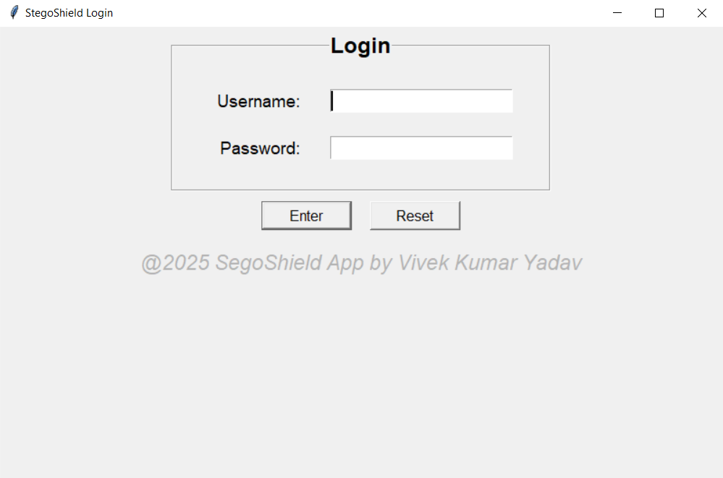
Figure 6.2.1

StegoShield(Main UI):
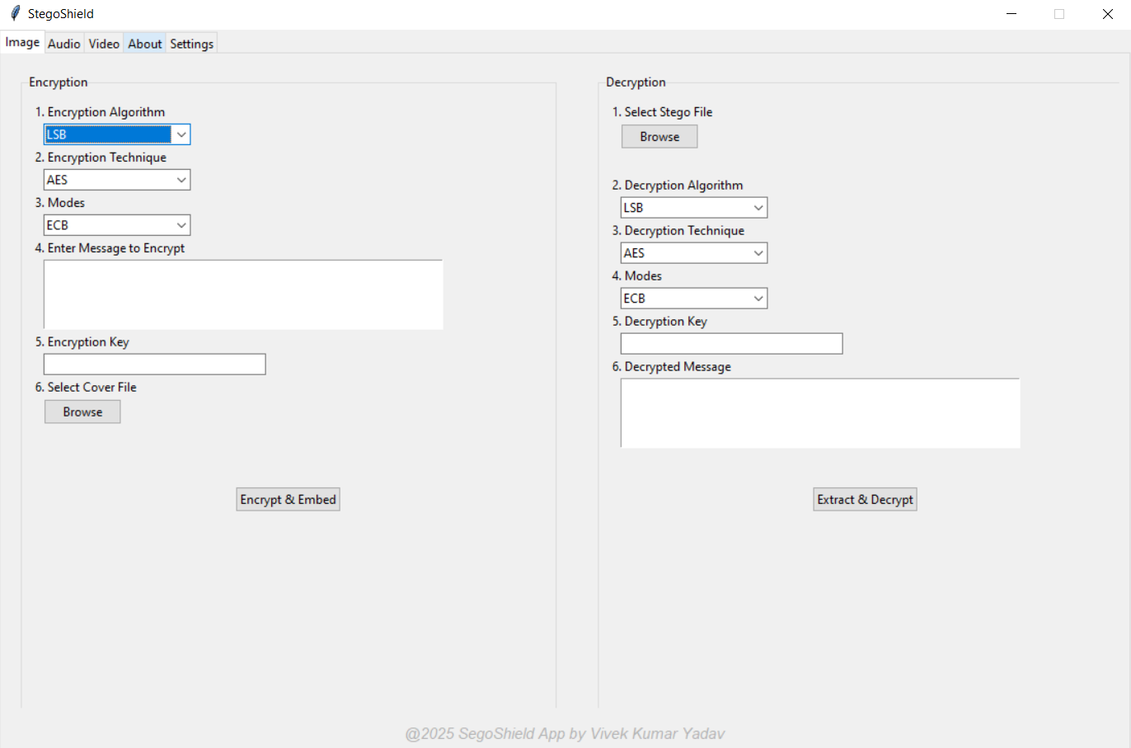
Figure 6.2.2

Image Algorithm, Techniques and Modes:
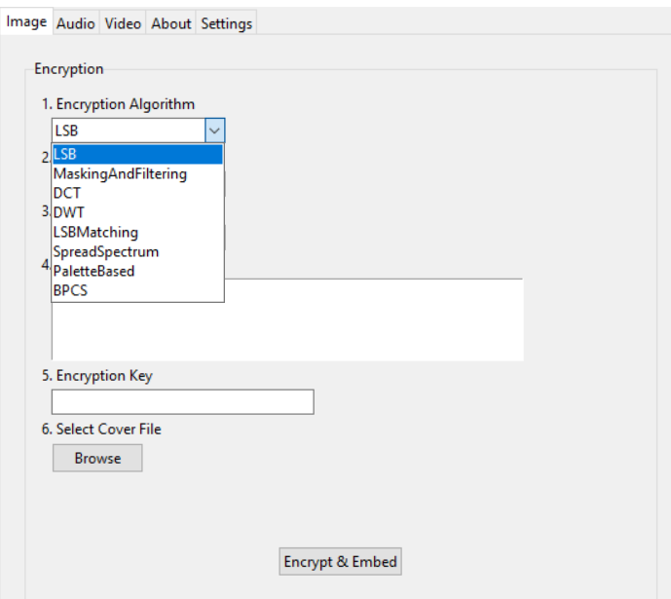
Figure 6.2.3-1

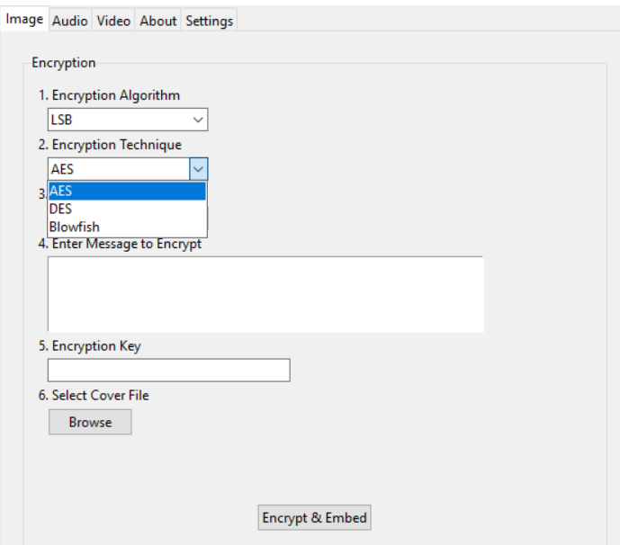
Figure 6.2.3-2
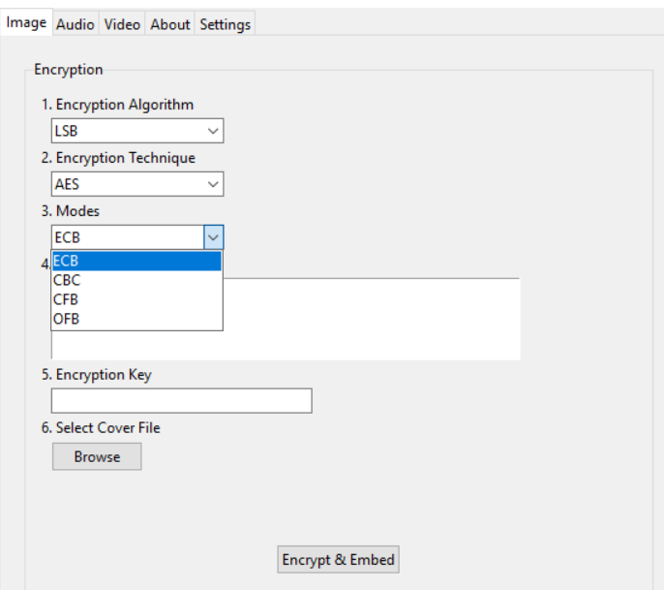
Figure 6.2.3-3

Audio Algorithm, Techniques and Modes:
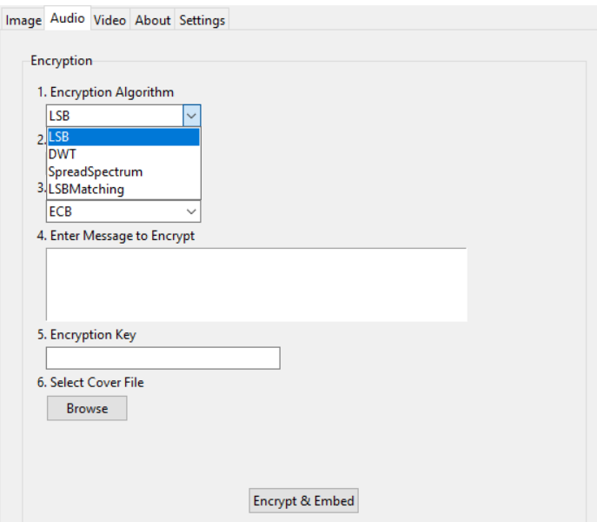
Figure 6.2.4-1

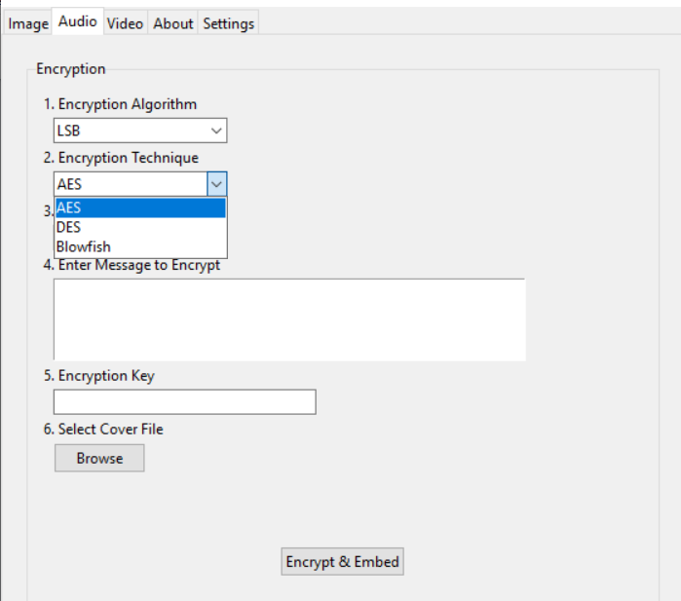
Figure 6.2.4-2

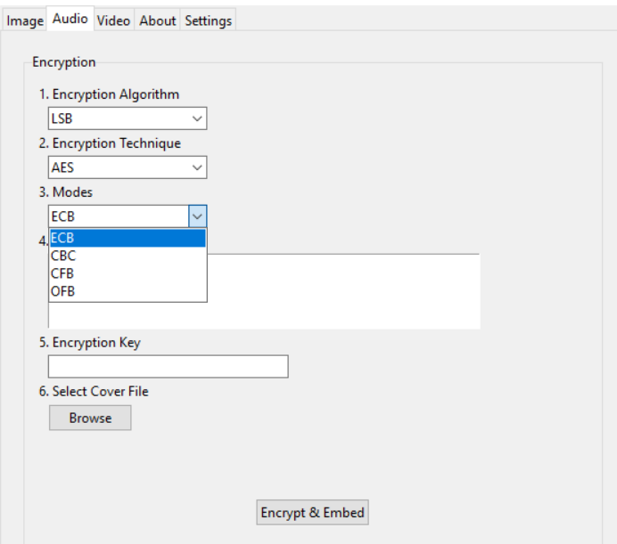
Figure 6.2.4-3

Video Algorithm, Techniques and Modes:
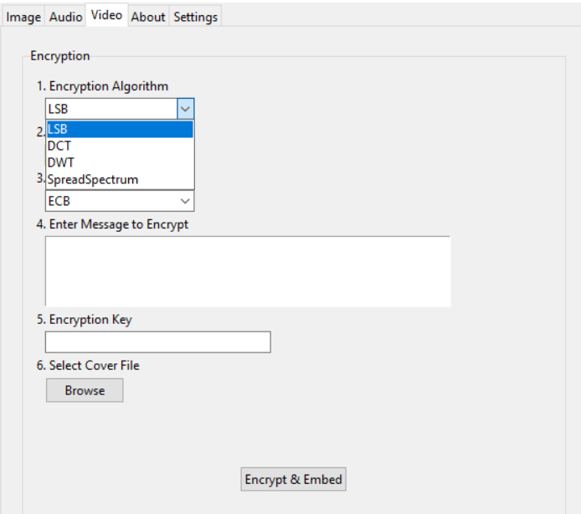
Figure 6.2.5-1

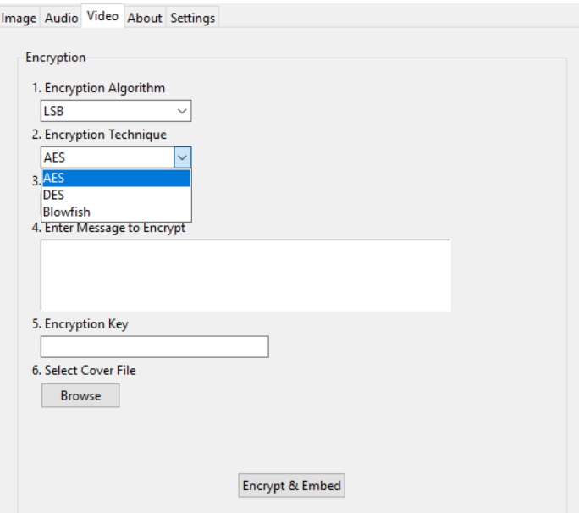
Figure 6.2.5-2

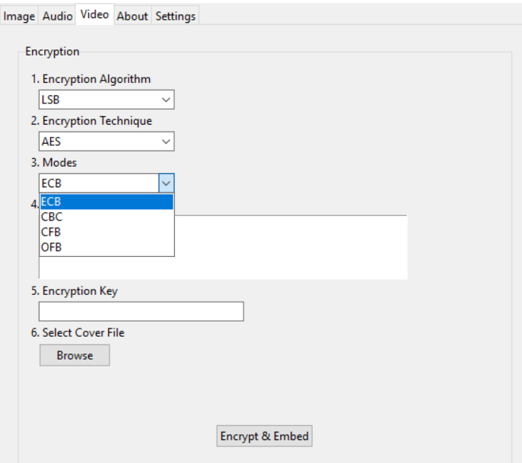
Figure 6.2.5-3

Image Encryption and Decryption:
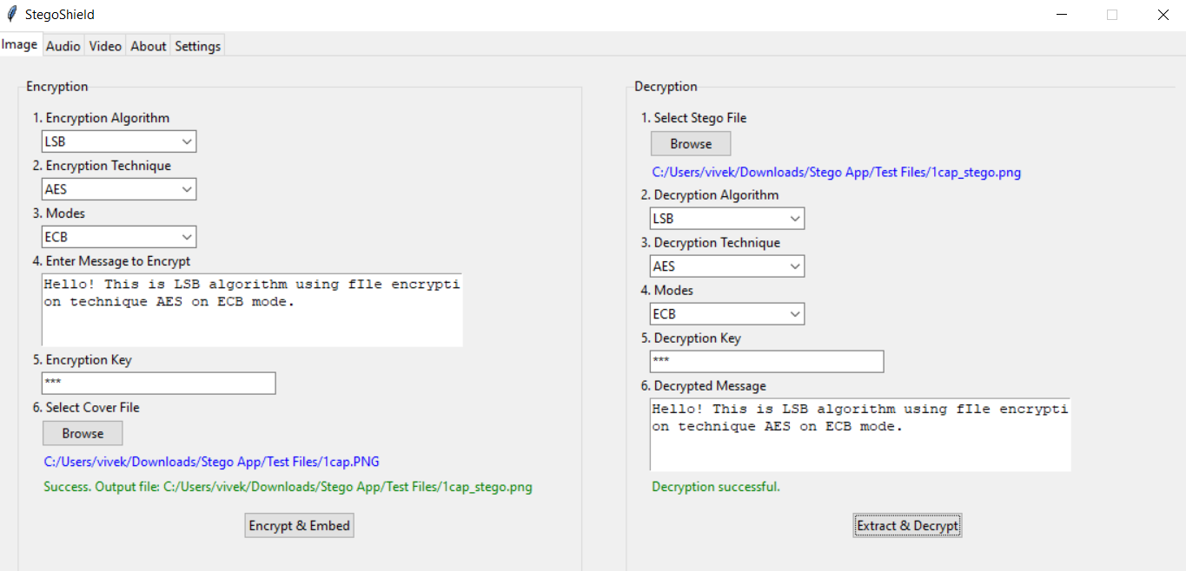
Figure 6.2.6-1
Figure 6.2.6-2
Audio Encryption and Decryption:
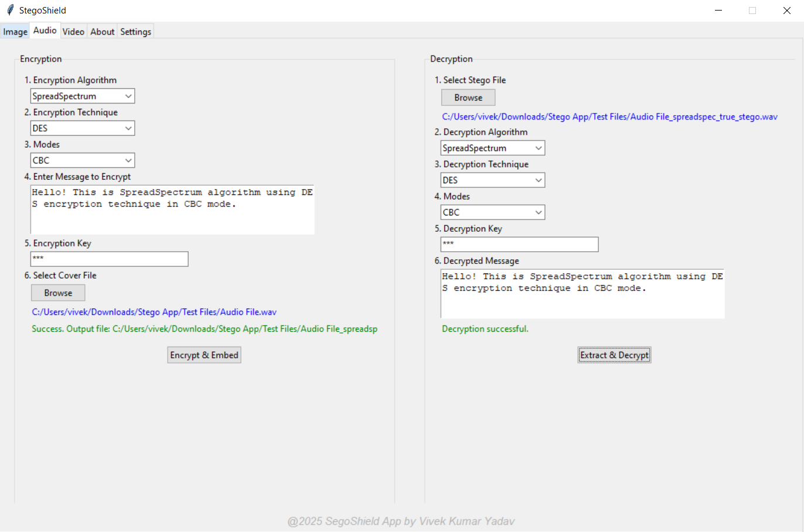
Figure 6.2.7-1
Figure 6.2.7-2

Video Encryption and Decryption:
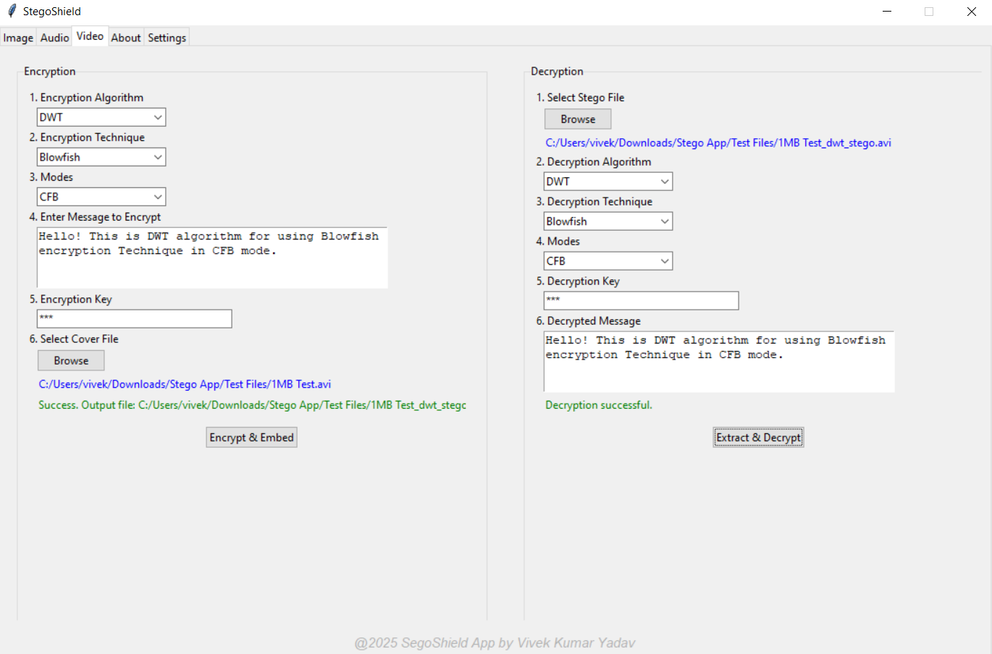
Figure 6.2.8-1

Figure 6.2.8-2

About:
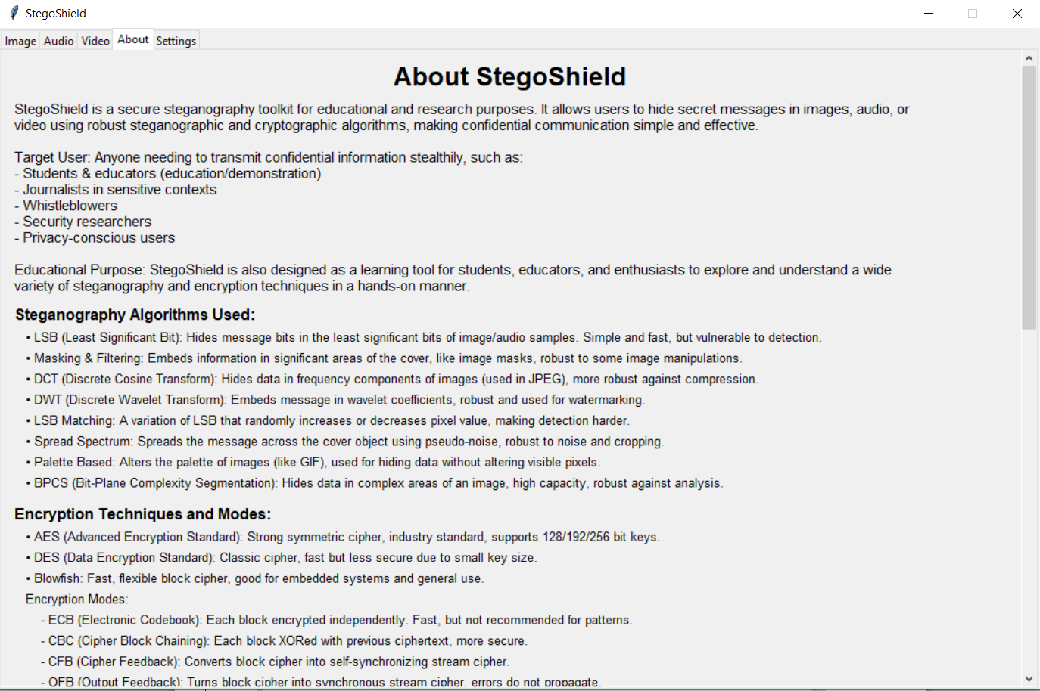
Figure 6.2.9-1

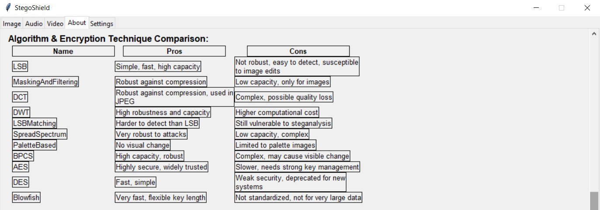
Figure 6.2.9-2

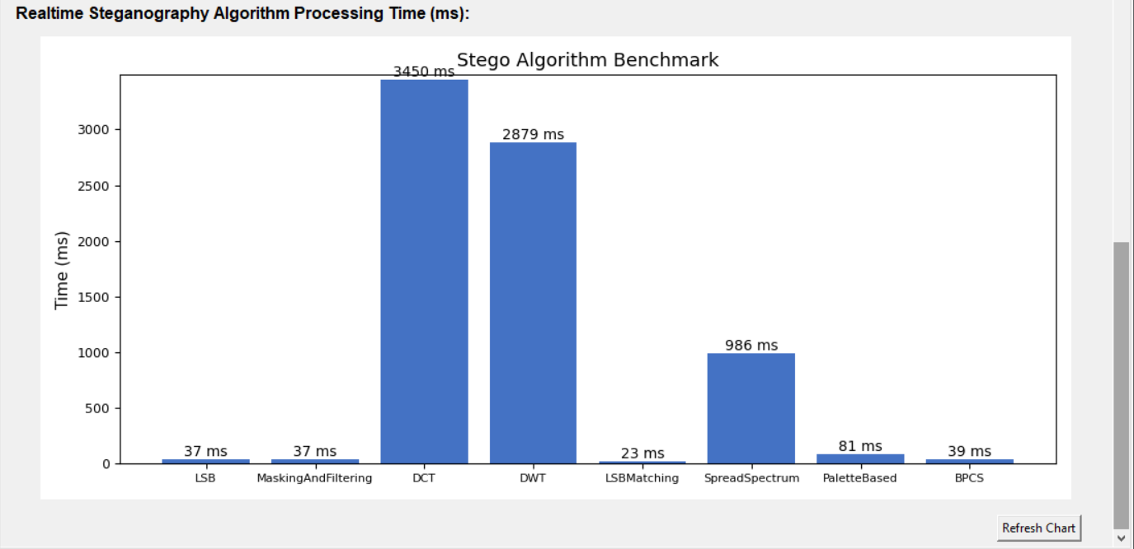
Figure 6.2.9-3

Settings:
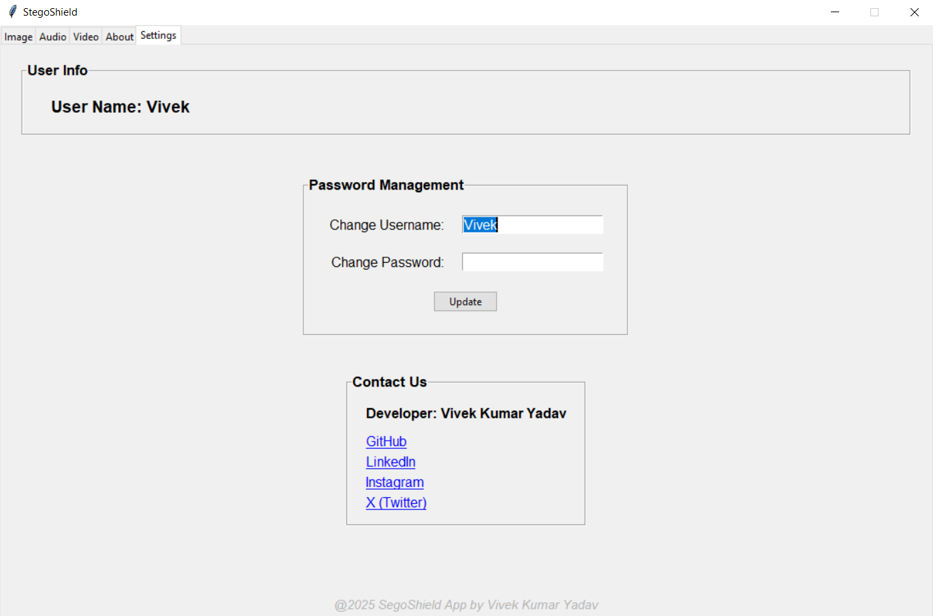
Figure 6.2.10

7. CONCLUSION AND FUTURE SCOPE
7.1 Conclusion
The StegoShield project successfully demonstrates the practical application of steganography and cryptography techniques for secure information hiding within digital media. Through a modular, user-friendly Python application, users can embed and extract confidential messages in various file formats—including images, audio, and video—while optionally utilizing industry-standard encryption algorithms for enhanced security. Comprehensive testing and a robust, extensible architecture ensure that StegoShield is reliable, maintainable, and adaptable to evolving user needs and security threats.

Throughout its development, StegoShield adhered to established software engineering methodologies, rigorous testing protocols, and best coding practices. The project not only meets its primary objectives—providing a secure, accessible, and flexible steganography tool—but also offers a foundation for further academic research and real-world deployment in scenarios such as confidential communication, watermarking, and digital rights management..

7.2 Future Scope
While StegoShield provides a comprehensive feature set in its current iteration, there are several areas for further improvement and expansion:

- Algorithm Expansion: Integration of advanced and emerging steganography techniques (e.g., deep learning-based methods, adaptive steganography) and support for additional encryption algorithms.

- Web and Mobile Versions: Development of web-based or mobile applications to increase accessibility and reach a broader audience.

- Enhanced User Experience: Improved GUI design, accessibility features, real-time progress indicators, and support for batch processing of multiple files.

- Cloud Integration: Enabling secure cloud storage and sharing options for stego files and encrypted data.

- Automated Steganalysis Tools: Incorporating tools for detection and analysis of steganographic content to support both security researchers and digital forensics experts.

- Support for More File Formats: Extending compatibility to more image, audio, and video formats.

- Internationalization: Adding multi-language support to cater to users worldwide.

- API Development: Providing a programmatic interface (API) for integration with other applications and workflows.

- Community Contributions: Encouraging open-source contributions, documentation enhancements, and collaborative research.

- Artificial Intelligence Integration: Utilizing AI and machine learning techniques for both improved steganography (e.g., adaptive, content-aware hiding) and for automated analysis or detection of stego content.

- Integration with Messaging Platforms: Direct integration with email clients, messengers, or social media for seamless secure sharing of stego files.

- Compliance and Standardization: Adapting the tool to comply with evolving international standards for data protection, privacy, and digital rights management.

- Educational Modules: Developing tutorials, simulation modules, or interactive labs to position StegoShield as a teaching tool in academic settings.

- Security Auditing and Reporting: Adding detailed security auditing logs, breach detection features, and reporting tools for enterprise or forensic use cases.

- Plugin Architecture: Allowing third-party developers to add custom algorithms or features through a plugin system, further enhancing extensibility and customization.

By pursuing these enhancements, StegoShield can remain at the forefront of secure communication technologies and continue to serve as a valuable resource for both academic and professional communities.

8. SYSTEM LIMITIATION
Despite the robust features and comprehensive testing of StegoShield, certain limitations exist due to technical, practical, and security considerations. Awareness of these limitations is essential for planning future improvements and for users to understand the operational boundaries of the application.

7.1 Technical Limitations
- Media Format Support:
StegoShield currently supports common file formats (such as PNG, BMP, WAV, and select video formats). It may not support all image, audio, or video formats, especially proprietary or highly compressed ones (e.g., JPEG, MP3, MP4 with certain codecs), which may lead to loss of hidden data or incompatibility.

- Payload Capacity:
The amount of data that can be hidden within a media file is limited by the file’s size and format. Attempting to embed large messages may result in noticeable distortion or failure.

- Algorithm Constraints:
Only a selected set of steganography and cryptography algorithms are available. The flexibility and security of the tool are bound by the strength and type of these implemented techniques.

- Processing Speed:
Embedding and extracting messages in large media files (especially videos) may be slow and resource-intensive, depending on hardware capabilities.

- Cross-Platform Issues:
While StegoShield is designed to be cross-platform, minor differences in library support or file handling may cause inconsistencies across Windows, Linux, and macOS.

7.2 Security & Usability Limitations
- No Steganalysis Resistance Guarantee:
Although StegoShield implements standard hiding techniques, sophisticated steganalysis tools or adversaries may still detect hidden data, especially if weak algorithms or inappropriate media files are used.

- Key Management:
The security of encrypted data depends on the strength and secrecy of user-provided keys. The application does not provide advanced key management or recovery features.

- User Error Handling:
Incorrect selection of algorithms, mismatched keys during extraction, or unsupported file formats may lead to failed operations or data loss. While the system provides error messages, it cannot always prevent user mistakes.

- No Network Security Features:
StegoShield focuses on file-based steganography and encryption. It does not offer secure file transfer, secure messaging, or cloud integration by default.

7.3 Mainenance & Extensibility Limitations
- Manual Algorithm Extension:
Adding new steganography or cryptography algorithms currently requires manual coding and integration. There is no plugin or marketplace system for third-party modules.

- Limited Automation:
The application’s batch processing and automation capabilities are limited. Users must perform most operations manually through the GUI.

- No Real-Time Collaboration:
StegoShield does not support multi-user, collaborative, or concurrent editing operations.

7.4 Legal & Ethical Limitations
- Potential for Misuse:
As with any security tool, StegoShield may be misused for unauthorized or illegal activities. The developers disclaim responsibility for unethical use.

- Jurisdictional Restrictions:
Some cryptography algorithms or steganography techniques may be restricted in certain countries. Users are responsible for compliance with local laws and regulations.

7.4 Other Limitations and Chanllenges
- Lack of Steganalysis Tools:
The current version does not integrate steganalysis modules to detect hidden content in files, which could help users verify the security of their stego files.

- Limited Accessibility Features:
While general usability is a focus, advanced accessibility features (such as screen reader support, high-contrast themes, or keyboard navigation for all actions) are not fully implemented.

- Scalability Constraints:
StegoShield is optimized for individual or small-scale use and may not perform efficiently in large enterprise or cloud-based deployments without further adaptation.

9. BILBOGRAPHY
Research Papers
1. "A Survey of Digital Image Steganography: Techniques, Advantages, and Limitations" Authors: M. Hussain, M. Hussain Journal of Computer Science, 2013, [https://thescipub.com/pdf/jcssp.2013.246-254.pdf](https://thescipub.com/pdf/jcssp.2013.246-254.pdf)

2. "Steganography and Steganalysis: Different Approaches" Authors: S. Katzenbeisser, F.A.P. Petitcolas Communications of the ACM, 2000, [https://dl.acm.org/doi/10.1145/347048.347070](https://dl.acm.org/doi/10.1145/347048.347070)

3. "A Review on Various Steganography Techniques" Authors: N. Provos, P. Honeyman
International Journal of Computer Applications, 2012 [https://pdfs.semanticscholar.org/6d59/5e64e4a7a8f8dcc5bfb9f1b6c6e2b6c9bfee.pdf](https://pdfs.semanticscholar.org/6d59/5e64e4a7a8f8dcc5bfb9f1b6c6e2b6c9bfee.pdf)

Books
1. "Information Hiding: Steganography and Watermarking - Attacks and Countermeasures" Authors: Stefan Katzenbeisser, Fabien A.P. Petitcolas Artech House, 2000 ISBN: 978-1580530354

2. "Cryptography and Network Security: Principles and Practice" Author: William Stallings Pearson, 7th Edition, 2016 ISBN: 978-0134444284

3. "Python Cookbook" Authors: David Beazley, Brian K. Jones O'Reilly Media, 3rd Edition, ISBN: 978-1449340377

Websites
1. PyCryptodome Documentation [https://www.pycryptodome.org/src/installation](https://www.pycryptodome.org/src/installation)

2. Pillow (PIL Fork) Documentation [https://pillow.readthedocs.io/en/stable/](https://pillow.readthedocs.io/en/stable/)

3. OpenCV Documentation [https://docs.opencv.org/master/](https://docs.opencv.org/master/)

4. GeeksforGeeks: Steganography in Python [https://www.geeksforgeeks.org/image-steganography-in-python/](https://www.geeksforgeeks.org/image-steganography-in-python/)

5. Wikipedia – Steganography [https://en.wikipedia.org/wiki/Steganography](https://en.wikipedia.org/wiki/Steganography)

Additional References
- Official Python Documentation: [https://docs.python.org/3/](https://docs.python.org/3/)

- GitHub Repositories on Steganography: [https://github.com/topics/steganography](https://github.com/topics/steganography)

- ResearchGate - Steganography Publications: [https://www.researchgate.net/topic/Steganography/publications](https://www.researchgate.net/topic/Steganography/publications)

